Bangladesh Medical Association (BMA)
List of Life Member-241
21. BMA Gopalganj Branch

Sl No | Voter No | Voter Details
1 | Voter No  LM-2100001  No Image | DR. SAHA NEROD CHANDRA  F/Name: Late Narayan Chandra Saha  M/Name:  BM & DC Reg. No:  NID:  Cell:  Address: 201, Kalibari Road Gopalganj  Blood Group: n_a
2 | Voter No  LM-2100002  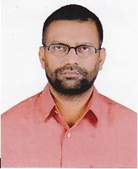 | DR. CHOWDHURY SHOFIQUL ALAM  F/Name: Chow. Abu Bakar Munshi  M/Name:  BM & DC Reg. No:  NID:  Cell:  Address: 116/1, Panchuria Gopalganj Gopalganj.  Blood Group: n_a
3 | Voter No  LM-2100003  No Image | DR. ARUN KANTI BISWAS  F/Name: Late Nilkanta Biswas  M/Name:  BM & DC Reg. No:  NID:  Cell:  Address: M/N- Sreemati Rajlakshmi Biswas. Arunodaya Bhaban, 177- Puraton Bazar Road, Gopalganj.  Blood Group:
4 | Voter No  LM-2100004  No Image | DR. MADHU MANGAL BISWAS  F/Name: Jadab Chandra Biswas  M/Name:  BM & DC Reg. No:  NID:  Cell:  Address: Thanapara Road Gopalganj.  Blood Group: n_a
5 | Voter No  LM-2100005  No Image | DR. J M. KAMRUL ISLAM  F/Name:  M/Name:  BM & DC Reg. No:  NID:  Cell:  Address: Gopalganj  Blood Group: n_a  TRANSFERED to BMA Dhaka City  LM-1405543
6 | Voter No  LM-2100005  No Image | DR. J M. KAMRUL ISLAM  F/Name:  M/Name:  BM & DC Reg. No:  NID:  Cell:  Address: Sadar Hospistal, Chandpur  Blood Group: n_a  TRANSFERED to BMA Dhaka City  LM-1405543
7 | Voter No  LM-2100006  No Image | DR. LAILA HUSNA BANU  F/Name:  M/Name:  BM & DC Reg. No:  NID:  Cell:  Address: Rangpur  Blood Group: n_a
8 | Voter No  LM-2100007  No Image | DR. FATEMA BEGUM  F/Name:  M/Name:  BM & DC Reg. No:  NID:  Cell:  Address: Gopalganj  Blood Group: n_a  TRANSFERED to BMA Dhaka City  LM-1405543
9 | Voter No  LM-2100008  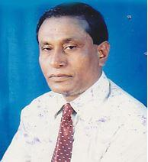 | DR. SIDDHESWAR MAZUMDAR  F/Name: Debendra Nath Mazumdar  M/Name:  BM & DC Reg. No:  NID:  Cell:  Address: TH & FPO Kashiani, Gopalganj.  Blood Group: n_a
10 | Voter No  LM-2100009 | DR. PROHLAD CHANDRA BISWAS  F/Name: Late Panchanon Biswas  M/Name:  BM & DC Reg. No:  NID:  Cell:  Address: M/N- Sarathi Biswas. Thanapara Gopalganj.  Blood Group: n_a
11 | Voter No  LM-2100010  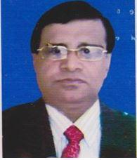 | DR. JADU NATH MAJUMDER  F/Name: Late Jadab Ch. Majumder  M/Name: Late Promila Majumder  BM & DC Reg. No: 11616  NID: 3515844835787  Cell: 01813985292  Address: Upazila Health Complex, Kotalipara, Gopalgonj  Blood Group: O+
12 | Voter No  LM-2100011  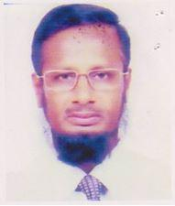 | DR. MD. NASIR UDDIN AHMED  F/Name: Late Iman Uddin  M/Name: Late, Basiran Nessa  BM & DC Reg. No: 7526  NID: 3514381492322  Cell: 01720160122  Address: Nabinbag, Gopalganj  Blood Group: B+
13 | Voter No  LM-2100012  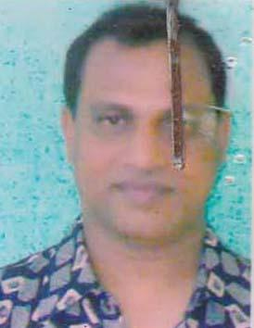 | DR. ASIT KUMAR MALLIK  F/Name: Late Satis Ch. Mallik  M/Name: Anyada Sundori Mallik  BM & DC Reg. No: 19406  NID: 3523203136698  Cell: 01711973037  Address: Medical Officer, Sadar Hospital, Gopalgonj  Blood Group:
14 | Voter No  LM-2100013  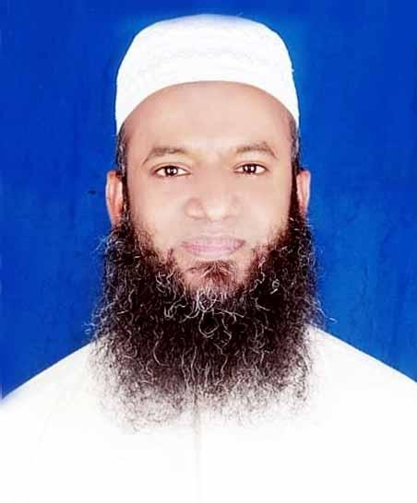 | DR. MD. SHIRAJUL ISLAM  F/Name: Md. Anishur Rahman  M/Name: Mrs. Ashia  BM & DC Reg. No: 31948  NID: 3523207135623  Cell: 01712203963  Address: 6/B, Junior Consultant Quarter Sadar Hospital, Gopalgonj  Blood Group: A+
15 | Voter No  LM-2100014 | DR. RANENDU SHEKHAR BISWAS  F/Name: Late Rash Behari Biswas  M/Name: Late Bilwa Rani Biswas  BM & DC Reg. No: 9149  NID: 3514394372763  Cell: 01711965518  Address: Sadar Hospital, Gopalgonj  Blood Group: B+
16 | Voter No  LM-2100015  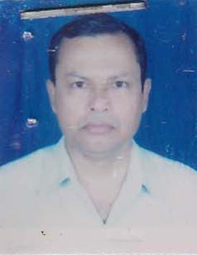 | DR. ASHIT RANJAN DAS  F/Name: Late Amullya Kumar Das  M/Name: Late Roma Rani Das  BM & DC Reg. No: 12020  NID: 3523204112705  Cell: 01715036199  Address: UH & FPO, Sadar Uopazilla, Gopalgonj  Blood Group: B+
17 | Voter No  LM-2100016  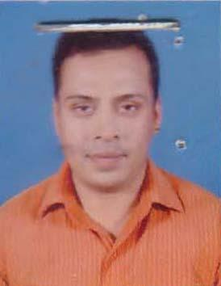 | DR. MOHAMMAD ASLAMUZZAMAN  F/Name: Md. Nuruzzaman  M/Name: Mrs. Jahanara Zaman  BM & DC Reg. No: 35958  NID: 3514327452131  Cell: 01715348583  Address: P.O+Vill- Kashiani, P.S- Kashiani, Dist- Gopalgonj  Blood Group: B+
18 | Voter No  LM-2100017  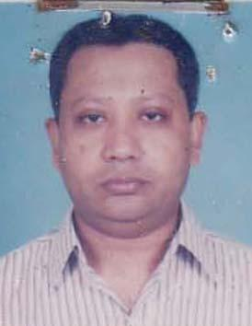 | DR. SHEIKH ABDULLAH AL MAHMUD  F/Name: Sheikh Mosharraf Hossain  M/Name: Monwara Mosharraf  BM & DC Reg. No: 21728  NID: 3523209135518  Cell: 01711470865  Address: Junior Consultant (Paediatrics), Sadar Hospital, Gopalgonj  Blood Group: B+
19 | Voter No  LM-2100018 | DR. PROSHANTA KUMAR SWARNAKAR  F/Name: Mr. Khagendra Nath Swarnakar  M/Name: Mrs. Ishani Bala Swarnakar  BM & DC Reg. No: 16839  NID: 3523209135364  Cell: 01718884842  Address: Sadar Hospital, Gopalgonj  Blood Group: O+
20 | Voter No  LM-2100019  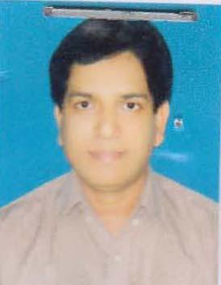 | DR. BALARAM ADHIKARI  F/Name: Nagendra Nath Adhikari  M/Name: Satadal Adhikari  BM & DC Reg. No: 23064  NID: 3525807945890  Cell: 01724907553  Address: Kamlapur, Muksudpur, Gopalgonj  Blood Group: A+
21 | Voter No  LM-2100020  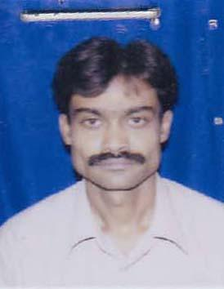 | DR. SUBRATA HALDER  F/Name: Chitta Ranjan Halder  M/Name: Aroti Halder  BM & DC Reg. No: 28903  NID: 3523209135797  Cell: 01711237016  Address: 129, Panchurea, Post & Dist- Gopalgonj  Blood Group: O+
22 | Voter No  LM-2100021 | DR. JIBANANDA HALDER  F/Name: Jagodish Chandra Halder  M/Name: Dulali Rani Halder  BM & DC Reg. No: 25155  NID: 2694810960020  Cell: 01711969261  Address: Doctor\'s Quater, District Hospital, Gopalganj  Blood Group: A+
23 | Voter No  LM-2100022  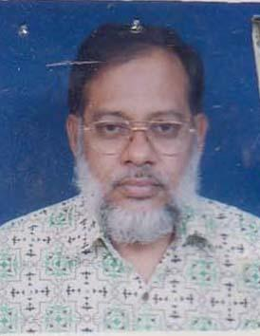 | DR. MD. MUNIR AHMED  F/Name: Alem Ahmed Howlader  M/Name: Mrs. Saleha Khatun  BM & DC Reg. No: 15561  NID:  Cell: 01715867876  Address: Sadar Hospital Gopalgonj  Blood Group: O+
24 | Voter No  LM-2100023  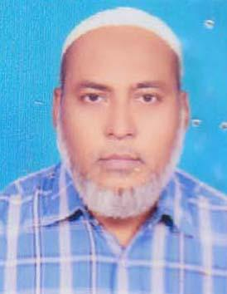 | DR. FARIDUL ISLAM CHOWDHURY  F/Name: Atahar Uddin Chowdhury  M/Name: Sufia Khatoon  BM & DC Reg. No: 16254  NID:  Cell: 01711052912  Address: R.M.O\'s Quarter, Sadar Hospital, Gopalgonj  Blood Group: O+
25 | Voter No  LM-2100024  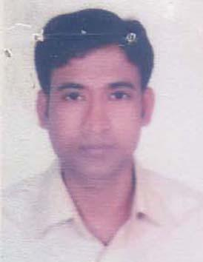 | DR. SHAIKH SHAH ALAM MUNIR  F/Name: Shaikh Mohammad Ali  M/Name: Halima Begum  BM & DC Reg. No: 42291  NID: 3515850874284  Cell: 01717388940  Address: Vill- Gunaher, Post: Nanikhir, P.S- Muksudpur, Gopalgonj  Blood Group: O+
26 | Voter No  LM-2100025  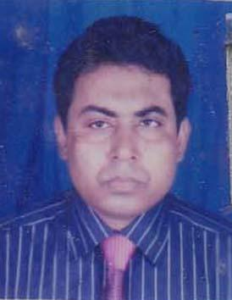 | DR. SHEIKH LUTFAR RAHMAN  F/Name: Late Abdul Barik Sheekh  M/Name: Late Hajera Khatun  BM & DC Reg. No: 27823  NID: 3523203136198  Cell: 01712073000  Address: 204, Kabarstan road, Miahpara, Gopalgonj  Blood Group: A+
27 | Voter No  LM-2100026  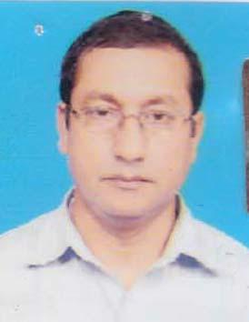 | DR. AMRITA LAL BISWAS  F/Name: Manindra Nath Biswas  M/Name: Shanti Kana Biswas  BM & DC Reg. No: 14757  NID: 3513273215820  Cell: 01712162741  Address: M.O.C.S., Gopalgonj  Blood Group:
28 | Voter No  LM-2100027  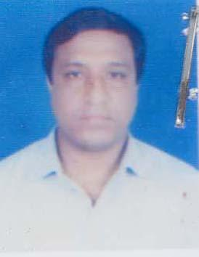 | DR. GOUTAM KUMAR BAKCHI  F/Name: Ganapati Bakchi  M/Name: Dulali Rani Bakchi  BM & DC Reg. No: 28954  NID: 3523205117446  Cell: 01715052850  Address: Dr. Farid Memorial Hospital 68, D.C. Road, Gopalgonj  Blood Group: B+
29 | Voter No  LM-2100028  No Image | DR. SUFIA SULTANA  F/Name: Abdur Rouf  M/Name:  BM & DC Reg. No: 7375  NID:  Cell:  Address: Dr. Farid Memorial Hospital, 68, D.C. Road, Gopalganj.  Blood Group:
30 | Voter No  LM-2100029  No Image | DR. ABID HASAN SHEIKH  F/Name: Farid Ahmed  M/Name:  BM & DC Reg. No: 7376  NID:  Cell:  Address: Dr. Farid Memorial Hospital, 68, D.C. Road, Gopalganj.  Blood Group:  E X P I R E D
31 | Voter No  LM-2100030  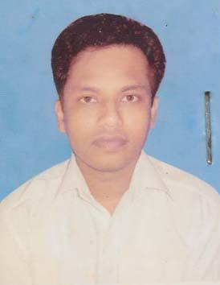 | DR.MUHAMMAD NAZMUL HAQUE LASKER  F/Name: Md. Dabir Uddin Lasker  M/Name: Mrs. Aleya Begum  BM & DC Reg. No: 53133  NID: 3513256177631  Cell: 01712076756  Address: House no: 128, College Road, Old Lanchghat, Gopalganj-8100  Blood Group: O+
32 | Voter No  LM-2100031  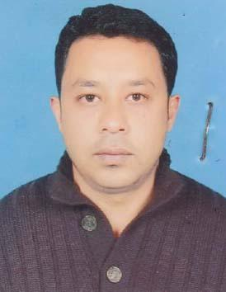 | DR. ABUL KALAM AZAD (PIKLU)  F/Name: Abul Kashem Mirdha  M/Name: Hamidha Akter  BM & DC Reg. No: 51320  NID:  Cell: 01759169117  Address: 91, Khulna Medical Collage Hospital  Blood Group: B+
33 | Voter No  LM-2100032 | DR. K. M. MONIM-UL-HABIB  F/Name: Md. Hasibur Rahman Khan  M/Name: Mrs. Hafizunnahar  BM & DC Reg. No: 35726  NID: 2699501913801  Cell: 01711981226  Address: Muksudpur Upazilla Health Complex, Muksudpur, Gopalgonj  Blood Group: A+
34 | Voter No  LM-2100033  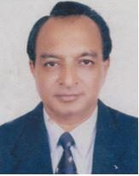 | DR. MD. ASADUZZAMAN  F/Name: Md. Aminul Islam  M/Name: Mrs. Jahanara Begum  BM & DC Reg. No: 8252  NID:  Cell: 01711735229  Address: Civil Surgeon, Gopalganj  Blood Group:
35 | Voter No  LM-2100034 | DR. PREMANANDA MONDOL  F/Name: Upendra Nath Mondol  M/Name: Late Ananta Debi Mondol  BM & DC Reg. No: 25827  NID: 5415447109909  Cell: 01914613714  Address: R.M.O, Upazila Health Complex, Kotalipara, Gopalgonj  Blood Group: A+
36 | Voter No  LM-2100035  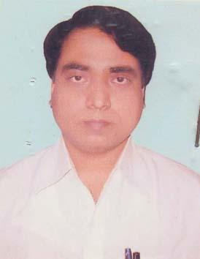 | DR. SUSHANTA BOIDYA  F/Name: Surjya Kanta Boidya  M/Name: Nanda Rani Boidya  BM & DC Reg. No: 45618  NID: 3515187662351  Cell: 01719457428  Address: Vill- Lakhanda, P.O.- Bhanger Hat, P.S.- Kotalipara, Dist: Gopalgonj  Blood Group: O+
37 | Voter No  LM-2100036  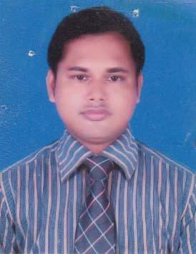 | DR. SUSHIL KUMAR BAGCHI  F/Name: Surjya Kanta Bagchi  M/Name: Mamota Bagchi  BM & DC Reg. No: 43013  NID: 3515171663686  Cell: 01921255690  Address: MO, UHC, Kotalipara, Gopalgonj  Blood Group: AB_po
38 | Voter No  LM-2100037  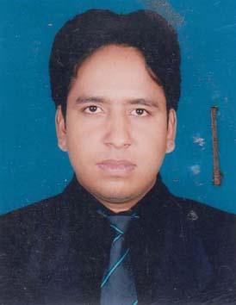 | DR. SHYAMAL CHANDRA BARAI  F/Name: Matilal Barai  M/Name: Bichitra Rani Barai  BM & DC Reg. No: 49626  NID: 6125214208082  Cell: 01719442987  Address: Vill: Pakhar Par, P.O: Bhanger Hat, P.S- Kotalipara, Dist- Gopalgonj  Blood Group: A+
39 | Voter No  LM-2100038  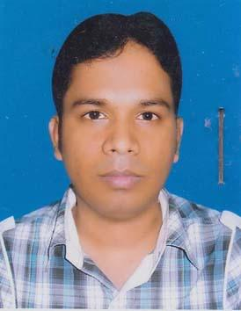 | DR. BHABANANDA BAROI  F/Name: Bhaktadas Baroi  M/Name: Laxmi Baroi  BM & DC Reg. No: 48770  NID: 2694811008814  Cell: 01717235279  Address: Vill+Post-Suagram, P.S- Kotalipara, Gopalgonj  Blood Group: A+
40 | Voter No  LM-2100039  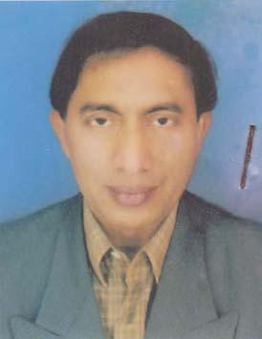 | DR. MD. HUMAYUN KABIR  F/Name: Md. Aminul Haque Munshi  M/Name: Aklima Begum  BM & DC Reg. No: 20867  NID: 3523209135593  Cell: 01711985461  Address: Doctor\'s Quarter, 250 Beded General Hospital, Gopalgonj  Blood Group: A+
41 | Voter No  LM-2100040  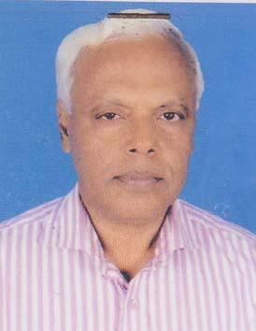 | DR. BIRENDRA NATH SINHA  F/Name: Late Manoranjan Sinha  M/Name: Shanti Lata Sinha  BM & DC Reg. No: 9241  NID: 35272  Cell: 01712705626  Address: 70, Banga Bandhu Sharak, Nur Hossain Chattar (Navana Building) Gopalgonj  Blood Group: B+
42 | Voter No  LM-2100041  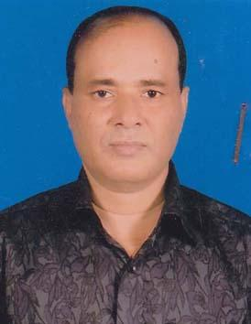 | DR. ANUP KUMAR MAZUMDER  F/Name: Late Dwezendra Nath Mazumder  M/Name: Malancha Mazumder  BM & DC Reg. No: 21669  NID: 3523209135510  Cell: 01816490911  Address: 3B/ Junior Consultent Quarter, 250 Beded General Hospital, Gopalgonj  Blood Group: O+
43 | Voter No  LM-2100042 | DR. GOLAM MOSTAFA  F/Name: Late Feroj Uddin Mollah  M/Name: Mrs. Rizia Begum  BM & DC Reg. No: 14735  NID: 3523209135525  Cell:  Address: Bangladesh Diagnostic Center, Chourangi Road, Gopalgonj  Blood Group: A+
44 | Voter No  LM-2100043  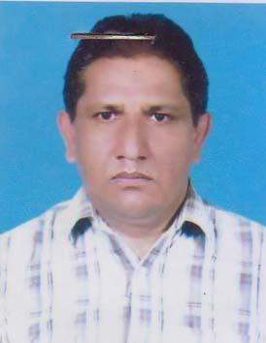 | DR. MD. SIRAJUL ISLAM MAHFUZ  F/Name:  M/Name:  BM & DC Reg. No: 16375  NID: 6710469091846  Cell:  Address: Junior Consultant E.N.T. 250 Bed General Hospital Gopalgonj  Blood Group: O+  TRANSFERED to BMA Dhaka City  LM-1405543
45 | Voter No  LM-2100044  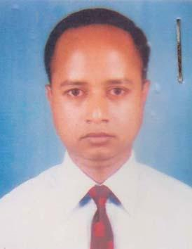 | DR. KAMALESH BISWAS  F/Name: Late. Jyotirmay Biswas  M/Name: Puspa Rani Biswas  BM & DC Reg. No: 41529  NID:  Cell: 01717535428  Address: Doctor\'s Quarter, UHC, Muksudpur, Gopalgonj  Blood Group: AB_po
46 | Voter No  LM-2100045  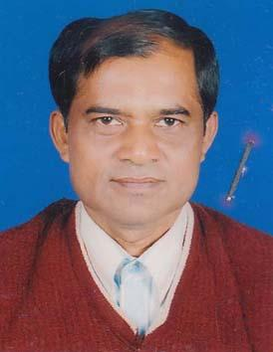 | DR. UDDHAB CHANDRA PANDAY  F/Name: Laxman Chandra Panday  M/Name: Sulekha Panday  BM & DC Reg. No: 22326  NID: 3513213303982  Cell: 01711067751  Address: MO (MCH-FP), Kashiani, Gopalgonj  Blood Group: B+
47 | Voter No  LM-2100046  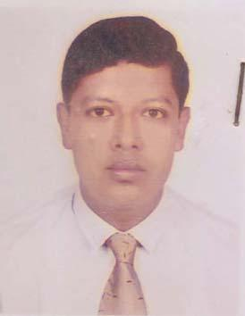 | DR. SHAFIQUR RAHMAN  F/Name: Habibur Rahman  M/Name: Nilufa Rahman  BM & DC Reg. No: 37764  NID:  Cell: 01711186964  Address: Vill: Ramdia College, P.O: Ramdia College, P.S: Kashiani, Dist: Gopalgonj  Blood Group: A+
48 | Voter No  LM-2100047  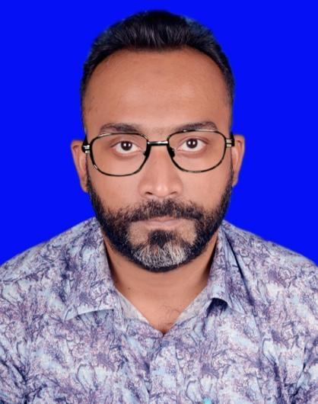 | DR MD SHAHJAHAN SIRAJ  F/Name: Md. Amran Chowdhury  M/Name: Kaniz Karim Bador Jahan  BM & DC Reg. No: 47558  NID: 4795129505136  Cell: 01911252932  Address: Medical Officer, UHC, Sadar, Gopalganj  Blood Group: A+
49 | Voter No  LM-2100048  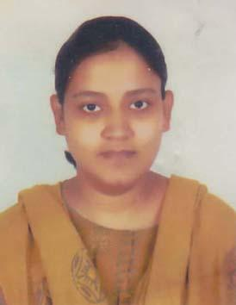 | DR. FARHANA ZAMAN  F/Name: Dr. Akhteruzzaman  M/Name: Mrs. Monowara Begum  BM & DC Reg. No: 45957  NID: 2691649101494  Cell: 01711242529  Address: Upazila Health Complex, Tungipara, Gopalgonj  Blood Group: A+
50 | Voter No  LM-2100049  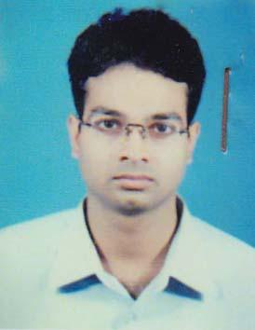 | DR. PROHLAD KARMAKER  F/Name: Late Anil Karmaker  M/Name: Puspa Karmaker  BM & DC Reg. No: 46494  NID: 3515883819177  Cell: 01916343025  Address: UHC, Tungi Para, Gopalgong  Blood Group: AB_po
51 | Voter No  LM-2100050  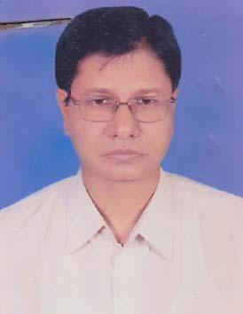 | DR. PABITRA KUMAR KUNDU  F/Name: Late Kalida Kundu  M/Name: Late Saraswati Kundu  BM & DC Reg. No: 15513  NID: 2910342313537  Cell: 01711571487  Address: Medical Officer, Upazila Health Complex, Tungipara, Gopalgonj  Blood Group: O+
52 | Voter No  LM-2100051  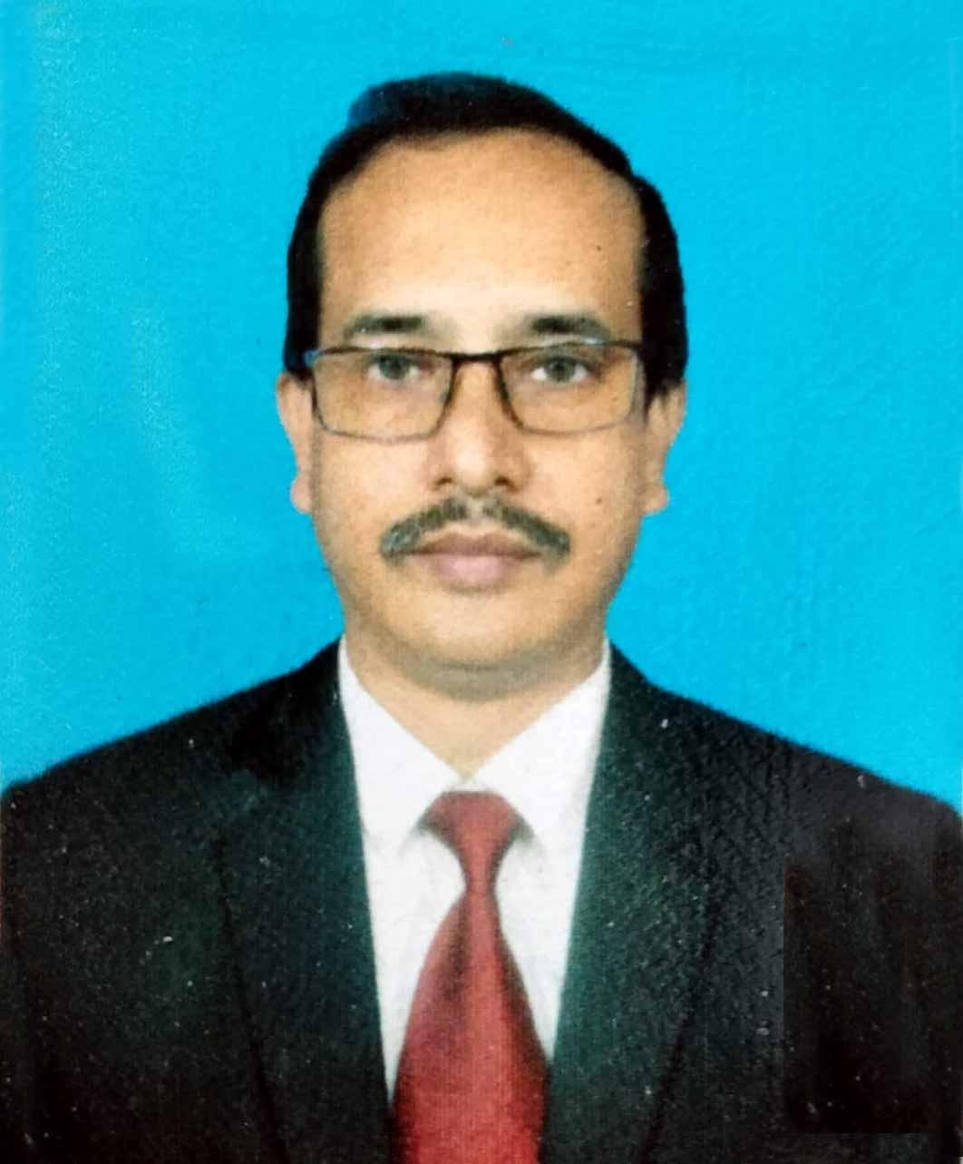 | DR. MD. QUIUME TALUKDER  F/Name: M.a. Mazid Talukder  M/Name: Feroza Begum  BM & DC Reg. No: 28986  NID: 2699059538865  Cell: 01712168561  Address: Vill- Naynakanda, Post- Nagerhat, Thana-Tungipara, Dist-Gopalgonj  Blood Group: O+
53 | Voter No  LM-2100052 | DR. AVISHEK BISWAS  F/Name: Dr. Arun Kanti Biswas  M/Name: Gita Rani Biswas  BM & DC Reg. No: 50649  NID: 3523202109104  Cell: 01558596204  Address: 177, Arunoday Bhavan, Puraton Bazzar Road, Gopalgonj  Blood Group: B+
54 | Voter No  LM-2100053  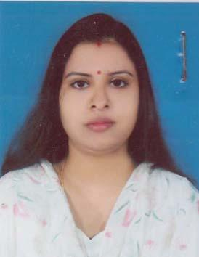 | DR. TITHI SARKAR  F/Name: Abani Ranjan Sarkar  M/Name: Malina Sarkar  BM & DC Reg. No: 50650  NID: 3521202109104  Cell: 01553699027  Address: 177, Arunaday Bhaban, Puratanbazar Road, Gopalgonj  Blood Group: A+
55 | Voter No  LM-2100054 | DR. NIRMAL KANTI BISWAS  F/Name: Kumud Ranjan Biswas  M/Name: Hashilata Biswas  BM & DC Reg. No: 39590  NID:  Cell: 01716206698  Address: 2/KA/2, 2nd floor, Khaza Bha Nawab Habibullah Road, Shabag, Dhaka  Blood Group: O+
56 | Voter No  LM-2100055  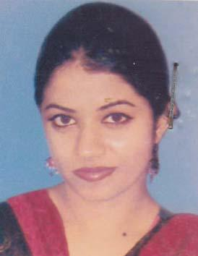 | DR. KAKALI HALDER  F/Name: Adhir Kumar Halder  M/Name: Amala Halder  BM & DC Reg. No: 51011  NID:  Cell: 01733252444  Address: 2/KA/2, 2nd floor, Khaza Bhaban, Habibullah Road, Shabag, Dhaka  Blood Group: B+
57 | Voter No  LM-2100056  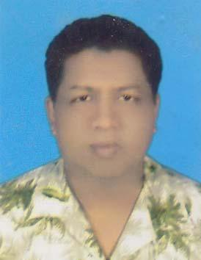 | DR. TARUN MANDAL  F/Name: Mr. Promatha Ranjan Mandal  M/Name: Mrs. Nirmala Mandal  BM & DC Reg. No: 19447  NID: 3515894928050  Cell: 01715655009  Address: RMO, Upazilla Health Complex, Kashiani, Gopalganj  Blood Group: B+
58 | Voter No  LM-2100057  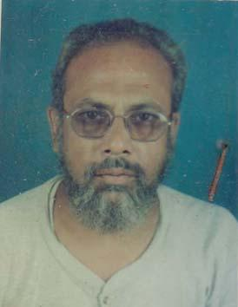 | DR. SHEIKH AHMAD KABIR  F/Name: Late Sheikh Noor Mohammad  M/Name: Mrs. Gule Jahan Nessa  BM & DC Reg. No: 7031  NID: 3523205118075  Cell: 01714322622  Address: DC Road, Chowrangi, Gopalganj  Blood Group: O+
59 | Voter No  LM-2100058  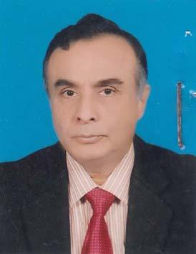 | DR. MD. MUSTAFIZUR RAHMAN MIAN  F/Name: Alhajj Md. Wali Ullah Mian  M/Name: Rahima Begum  BM & DC Reg. No: 10948  NID: 2696352206525  Cell: 01730324778  Address: Civil Surgion, Gopalganj  Blood Group: B+
60 | Voter No  LM-2100059 | DR. MOHAMMAD MASUDUR RAHMAN MOLLAH  F/Name: Mohammad Sherjan Ali Mollah  M/Name: Sahera Khatun  BM & DC Reg. No: 37395  NID: 5827407126106  Cell: 01712280747  Address: Resident Surgeon (R.S) 250 Beded General Hospital, Gopalgong  Blood Group: O+
61 | Voter No  LM-2100060  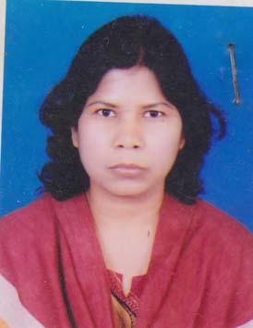 | DR. RINA RANI SAHA  F/Name: Raghu Nath Saha  M/Name: Late-bina Rani Saha  BM & DC Reg. No: 33863  NID:  Cell: 01712622715  Address: Assistant Professor (Gynae) Sheikh Sayera Khatun Medical College, Gopalgonj.  Blood Group: B+
62 | Voter No  LM-2100061  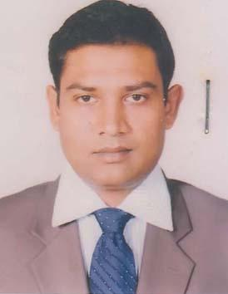 | DR. IFTEQUAR ALAM  F/Name: A.T.M. SHAHIDUL ALAM  M/Name: Momotaz Shirin  BM & DC Reg. No: 42194  NID:  Cell: 01717536054  Address: 184, Udayan Road, Gopalgonj  Blood Group: O+
63 | Voter No  LM-2100062  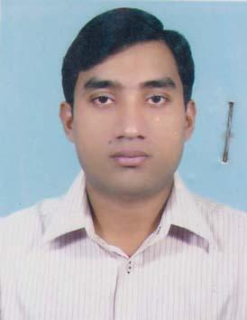 | DR. A.F.M JULFIKAR  F/Name: Md. Shahjahan Ali  M/Name: Salma Begum  BM & DC Reg. No: 41935  NID: 3514374422698  Cell: 01748182715  Address: 250- Bedded General Hospital, Gopalganj  Blood Group: O+
64 | Voter No  LM-2100063  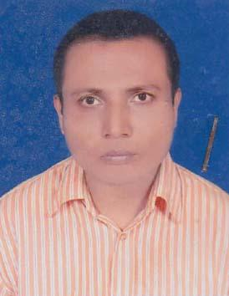 | DR. DIPANKAR BISWAS  F/Name: Jagananda Biswas  M/Name: Parul Biswas  BM & DC Reg. No: 39902  NID:  Cell: 01712257187  Address: H-5 Sador Hospital Quarter Gopalgonj  Blood Group: B+
65 | Voter No  LM-2100064  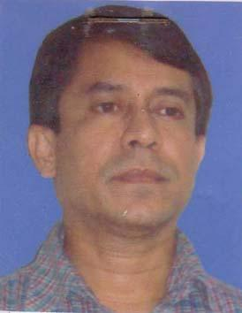 | DR. PARIMAL SARKAR  F/Name: Late Dhirendra Nath Sarkar  M/Name: Late Sushila Sarkar  BM & DC Reg. No: 11418  NID: 5728702105247  Cell: 01817400910  Address: Chest Disease Clinic, Gopalganj  Blood Group: A+
66 | Voter No  LM-2100065 | DR. MD. RAZIBUL BARI  F/Name: Md. Abdul Barek Mia  M/Name: Hosne Ara Begum  BM & DC Reg. No: 41925  NID:  Cell: 01711115355  Address: C/O- Masudur Rahman, National Science Museum, Agargaon, Dhaka-1207  Blood Group: A+
67 | Voter No  LM-2100066  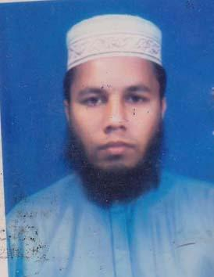 | DR. KHAJA HUMAUN KABIR  F/Name: Late- Shahjahan Gazi  M/Name: Sorupjan Bibi  BM & DC Reg. No: 33652  NID: 4820609432285  Cell: 01916151273  Address: Dept. of Paediatrics, Sher-e-Bangla Medical College Hospital, Barishal  Blood Group: B+
68 | Voter No  LM-2100067  No Image | DR. MD. KAMAL UDDIN  F/Name: Late Md. Wali Uddin Bhuiyan  M/Name:  BM & DC Reg. No: 18471  NID:  Cell:  Address: 250 Beded General Hospital, Gopalginj.  Blood Group:
69 | Voter No  LM-2100068  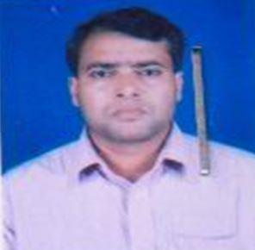 | DR. GOBINDA CHANDRA SAHA  F/Name: Nabadwip Chandra Saha  M/Name:  BM & DC Reg. No: 21594  NID:  Cell:  Address: Associate Professor & Head Department, Of Surgery, Sheikh Syera Khatoon Medical College Gopalganj  Blood Group:
70 | Voter No  LM-2100069  No Image | DR. MOHAMMAD AMINUL ISLAM MIAN  F/Name: Jalal Uddin Ahmed  M/Name:  BM & DC Reg. No:  NID:  Cell:  Address: UH & FPO., Muksudpur, Gopalganj.  Blood Group:
71 | Voter No  LM-2100070  No Image | DR. MD. MANIRUZZAMAN KHAN  F/Name: Late Mlvi. Kudrat Ali Khan  M/Name:  BM & DC Reg. No:  NID:  Cell:  Address: Indoor Medical Officer, MMCH Maynmonshigh  Blood Group:
72 | Voter No  LM-2100071  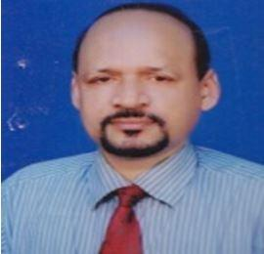 | DR. MAHESH CHANDRA DHALI  F/Name: Late Manindra Nath Dhali  M/Name: Late Sarojini Dhali  BM & DC Reg. No: 18978  NID:  Cell: 01711668236  Address: Senior Consultant (Eye Dept.) 250 Beded General Hospital, Gopalginj.  Blood Group: B+
73 | Voter No  LM-2100072  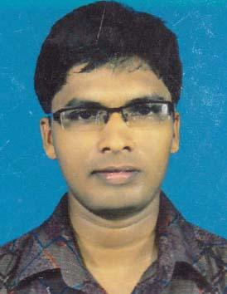 | DR. SOUMEN SARKAR  F/Name: Anadi Ranjan Sarkar  M/Name: Souravi Sarkar  BM & DC Reg. No: 62963  NID: 0695111184843  Cell: 01728748277  Address: UHC- Sadar Gopalgonj  Blood Group: B+
74 | Voter No  LM-2100073  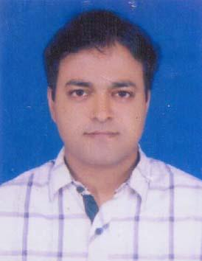 | DR. M. MEZBAH AHMED  F/Name: Md. Rais Uddin Munshi  M/Name: Momotaj Begum  BM & DC Reg. No: 58960  NID: 2697556419152  Cell: 01717235151  Address: 108/21-KA, Keshab Laal Road, Pabla, Daulatpur, Khulna  Blood Group: B+
75 | Voter No  LM-2100074  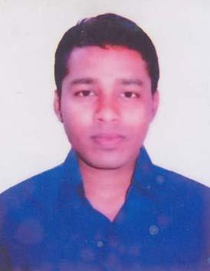 | DR. MD. GALIB RAIHAN  F/Name: S.M. Fayek-Uz-Zaman  M/Name: Rumia Khanam  BM & DC Reg. No: 63860  NID: 9196201102650  Cell: 01723435032  Address: UHC, Sadar, Gopalganj  Blood Group: B+
76 | Voter No  LM-2100075  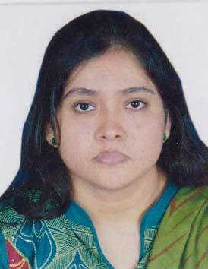 | DR. GAYATREE BISWAS  F/Name: Dr. Arun Kanti Biswas  M/Name: Gita Biswas  BM & DC Reg. No: 54113  NID: 3523202109234  Cell: 01714001058  Address: 177, Arunodoy Bhaban, Puratan Bazar Road, Gopalgonj  Blood Group: B+
77 | Voter No  LM-2100076  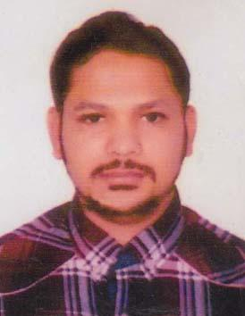 | DR. MD. SHAMIMUR RAHMAN  F/Name: Md. Mazibur Rahman  M/Name: Momesha Begum  BM & DC Reg. No: 55409  NID:  Cell: 01682002814  Address: Flat-B5, H # 21, R # 17, S # 13, Uttara Model Town, Dhaka  Blood Group: A+
78 | Voter No  LM-2100077  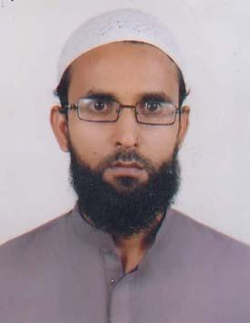 | DR. MUHAMMAD ROBIUL HOQUE  F/Name: Muhammad Anamul Hoque  M/Name: Zobaida Khatun  BM & DC Reg. No: 55090  NID: 6125217236021  Cell: 01818312387  Address: Vill/Post/Thana- Kashiani, Dist-Gopalganj  Blood Group: O+
79 | Voter No  LM-2100078  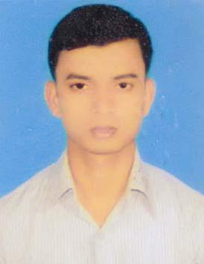 | DR. SABUJ SIKDER  F/Name: Abul Sikder  M/Name: Papia Begum  BM & DC Reg. No: 60539  NID: 8198510366880  Cell: 01914994560  Address: Vill-Bandle, Post+Upz- Kotalipara, Dist- Gopalgonj  Blood Group: A+
80 | Voter No  LM-2100079 | DR. PALLAB ADHIKARY  F/Name: Atul Chandra Adhikary  M/Name: Ashalata Adhikary  BM & DC Reg. No: 58086  NID: 0695111185384  Cell: 01712878037  Address: Upazila Health Complex, Tungipara, Gopalgonj  Blood Group: A+
81 | Voter No  LM-2100080  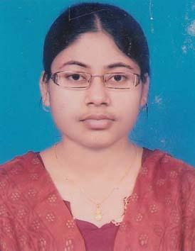 | DR. KACHI BARAI  F/Name: Santosh Kumar Barai  M/Name: Suchitra Rani Sarker  BM & DC Reg. No: 67234  NID: 19892696653272572  Cell: 01797016566  Address: Doctors Quarters, Tungipara Health Complex, Gopalgonj  Blood Group: B+
82 | Voter No  LM-2100081  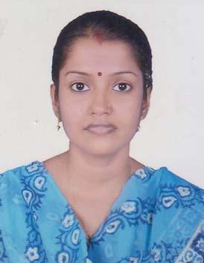 | DR. ZHUMA RANI PAUL  F/Name: Mr. Nakul Chandra Paul  M/Name: Mrs. China Rani Paul  BM & DC Reg. No: 59675  NID: 5925604157637  Cell: 01717690550  Address: Officers Quarter, Kotwalipara Upazilla Health Complex, Kotwalipara, Gopalgonj  Blood Group: B+
83 | Voter No  LM-2100082  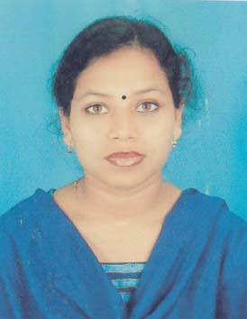 | DR. BITHI MALLIK  F/Name: Haran Chandra Mallik  M/Name: Dipali Rani Mallik  BM & DC Reg. No: 57870  NID: 3323005149608  Cell: 01916622148  Address: Vill. Bagan Uttarpara, Post- Kotalipara, Dist-Gopalganj  Blood Group: B+
84 | Voter No  LM-2100083  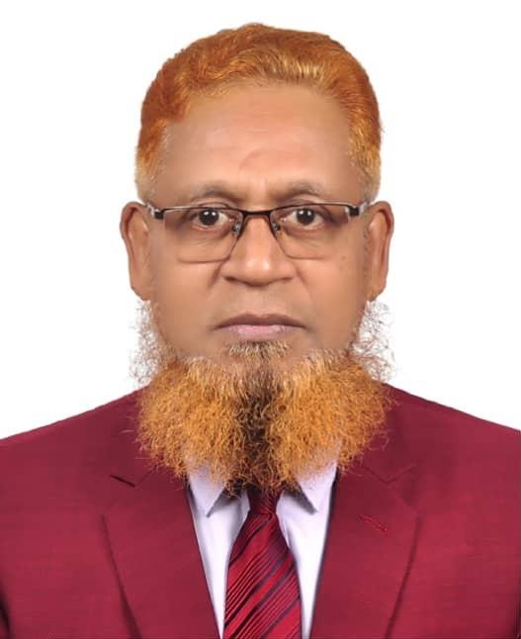 | DR. MD. MONOWER HOSSAIN  F/Name: Md. Abul Hashem Molla  M/Name: Monowara Begum  BM & DC Reg. No: 18983  NID: 3514388435768  Cell: 01712285410  Address: Director, Sheikh Sayera Khatun Medical College Hospital, Gopalganj  Blood Group: A+
85 | Voter No  LM-2100084  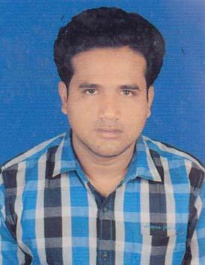 | DR. ARUP RATAN BARAI  F/Name: Sudhir Kumar Barai  M/Name: Purabi Mondal  BM & DC Reg. No: 45105  NID: 3515163607281  Cell: 01717753374  Address: Upazilla Health Complex Kotalipara, Gopalgonj  Blood Group:
86 | Voter No  LM-2100085  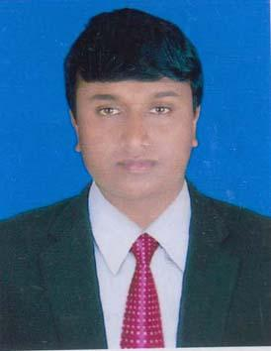 | DR. JYOTIRMAYA BALA  F/Name: Joydeb Chandra Bala  M/Name: Kanchan Bala  BM & DC Reg. No: 49535  NID: 7917631461315  Cell: 01717407722  Address: Doctor\'s Quarter UHC Tungipara, Gopalganj  Blood Group: A+
87 | Voter No  LM-2100086  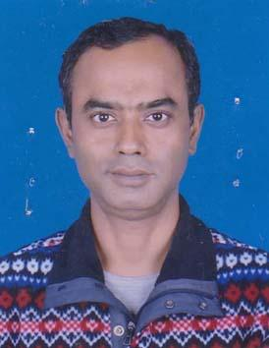 | DR. MD. ABU BAKAR SIDDIQUE  F/Name: A. Sattar Mollah  M/Name: Mrs. Saleha Begum  BM & DC Reg. No: 30496  NID:  Cell: 01554300810  Address: 220 Model School Road, Mahdi Vila 2nd Floor, Gopalgonj  Blood Group: O+
88 | Voter No  LM-2100087  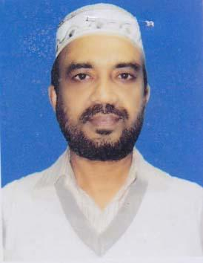 | DR. NIAZ MOHAMMAD  F/Name: Late Joynal Abedin Mollah  M/Name: Hasina Begum  BM & DC Reg. No: 25110  NID: 3523205118366  Cell: 01711703792  Address: Hospital Quarter, 250 Bedded General Hospital, Gopalganj  Blood Group: B+
89 | Voter No  LM-2100088  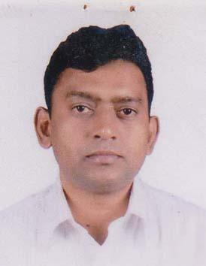 | DR. MOHAMMAD EMDADUL HAQUE  F/Name: Late S.k. Sherajul Haque  M/Name: Khadiza Begum  BM & DC Reg. No: 25550  NID:  Cell: 01711705296  Address: Vill- Gosherchar East Para, P.O+PS- Sadar, Gopalganj  Blood Group: B+
90 | Voter No  LM-2100089  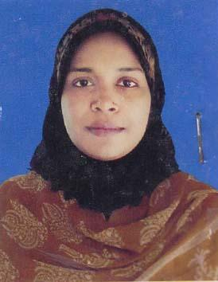 | DR. FARIA ZAMAN  F/Name: Md. Akhter Uzzaman  M/Name: Farida Zaman  BM & DC Reg. No: 40233  NID: 2696828267005  Cell: 01712945481  Address: Vill- Gosherchar East Para, Sader, Gopalganj  Blood Group: A+
91 | Voter No  LM-2100090  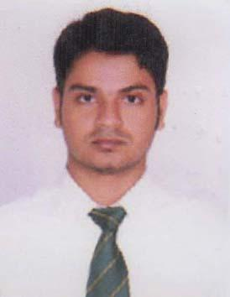 | DR. SK. WOALI ULLAH  F/Name: SK. Yeasin Ullah  M/Name: Mrs. Doly Aktar  BM & DC Reg. No: 59816  NID: 8719087867649  Cell: 01717003856  Address: Civil Surgeon Office, Gopalgonj  Blood Group: O+
92 | Voter No  LM-2100091  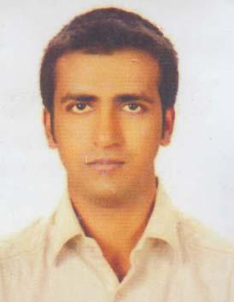 | DR. TANVIR AHMED  F/Name: Hannan Ali Swarder  M/Name: Feroza Begum  BM & DC Reg. No: 53760  NID: 19861594116939731  Cell: 01717025358  Address: 158, Sobujbag Road, Chandmari, Gopalgonj  Blood Group: AB+
93 | Voter No  LM-2100092  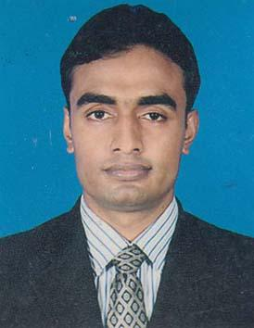 | DR. MASUD KARIM  F/Name: Abul Kashem Miah  M/Name: Mahamuda Begum  BM & DC Reg. No: 46141  NID: 2694812069534  Cell: 01715168295  Address: Doctor\'s Quarter, Upazilla Health Complex, Muksudpur, Gopalganj  Blood Group: A+
94 | Voter No  LM-2100093  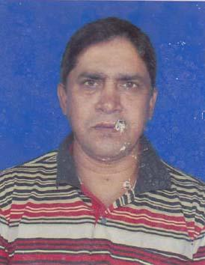 | DR. B. M. MONIRUZZAMAN  F/Name: Md. Abul Kashem Bhuiyan  M/Name: Mrs. Rabeya Bhuiyan  BM & DC Reg. No: 20563  NID: 3523201100551  Cell: 01711362142  Address: 400/3 C & B Road, Kuadanga, Gopalgonj  Blood Group: B+
95 | Voter No  LM-2100094  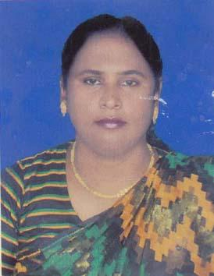 | DR. LUTFUN NAHAR  F/Name: Md. Sirajul Islam  M/Name: Mahamuda Begum  BM & DC Reg. No: 24967  NID: 3523201100552  Cell: 01711367647  Address: House No- 400/3, C & B Road Kuadanga, Gopalgonj  Blood Group: A+
96 | Voter No  LM-2100095  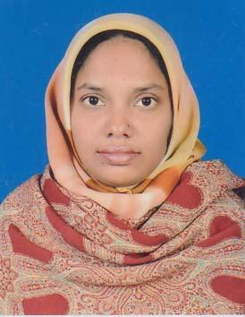 | DR. NIKSAR AKHTER  F/Name: Md. Yunus Ali  M/Name: Mrs. Nirzona Begum  BM & DC Reg. No: 34801  NID: 3523209135523  Cell: 01716667916  Address: Const. Quarter, 250 Bedded General Hospital, Gopalgonj  Blood Group: A+
97 | Voter No  LM-2100096  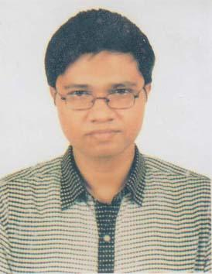 | DR. GAZI YEASINUL ISLAM  F/Name: Gazi Nurul Islam  M/Name: Nasima Islam  BM & DC Reg. No: 56795  NID: 4795127458870  Cell: 01716715995  Address: Vill- Arpara, Post. Bhararhat, Upazilla & Dist- Gopalganj  Blood Group: O+
98 | Voter No  LM-2100097  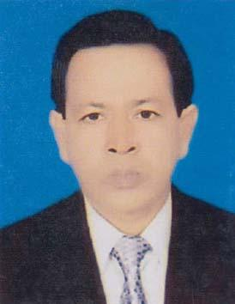 | DR. TAPAN MAJUMDER  F/Name: Late Samarendra Nath Majumder  M/Name: Rani Bala Majumder  BM & DC Reg. No: 15413  NID: 3514320370675  Cell: 01712064607  Address: R.M.O 250 Beded General Hospital, Gopalgonj  Blood Group: B+
99 | Voter No  LM-2100098  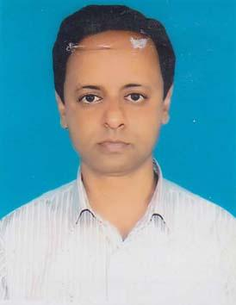 | DR. PROBIR KUMAR BANERJEE  F/Name: Profulla Kumar Banerjee  M/Name: Gouri Rani Banerjee  BM & DC Reg. No: 32409  NID: 3513217149204  Cell: 01715285746  Address: Vill- Karargati, P.O- Verarhat, P/S+Dist.- Gopalganj  Blood Group: A+
100 | Voter No  LM-2100099  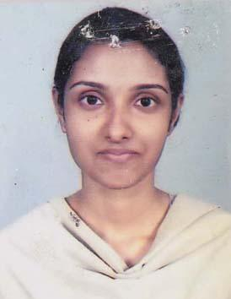 | DR. JOYASHREE CHAKRABORTY  F/Name: Mukunda Chakraborty  M/Name: Shanti Chakraborty  BM & DC Reg. No: 52057  NID: 1594121397774  Cell: 01190745360  Address: Vill: Karargati, P.O- Verarhat, Dist- Gopalgonj  Blood Group: A+
101 | Voter No  LM-2100100  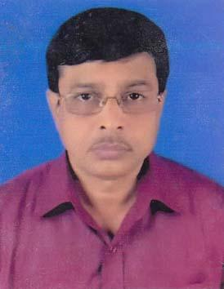 | DR. MD. ZAFRUL BARI RASHED  F/Name: A.K.M. Syful Islam  M/Name: Begum Jahanara Chowdhury  BM & DC Reg. No: 12567  NID: 4795122403058  Cell: 01913461901  Address: Flat no-5c, Nafco Shopping Complex, DC Road, Gopalgonj  Blood Group: B+
102 | Voter No  LM-2100101  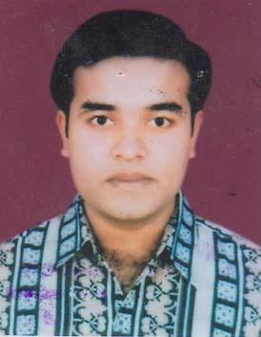 | DR. MD. JASIM UDDIN  F/Name: MD. Abdul Hannan  M/Name: Rowshan Ara Nargis  BM & DC Reg. No: 59102  NID: 9196208195935  Cell: 01711447892  Address: \"Monihar\" 231 Chandmari, First Bil... 15t Floor, Chandmari, Gopalgonj  Blood Group: B+
103 | Voter No  LM-2100102 | DR. MD. NAZMUL HUDA  F/Name: Sultan Ahmed  M/Name: Nazma Sultana  BM & DC Reg. No: 51814  NID: 8198510364756  Cell: 01674922674  Address: UHC Sadar, Gopalganj  Blood Group:
104 | Voter No  LM-2100103  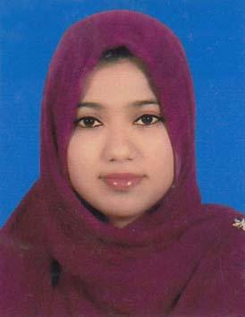 | DR. SHAHANAZ PARVIN  F/Name: Md. Wahedul Islam  M/Name: Shamima Akter  BM & DC Reg. No: 62674  NID: 1916765152890  Cell: 01674943321  Address: UHC, Sadar, Gopalganj  Blood Group: B+
105 | Voter No  LM-2100104  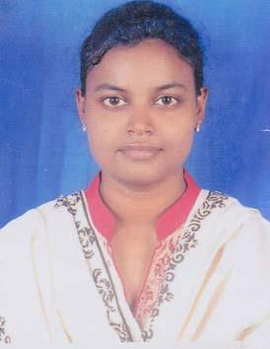 | DR. KUNTALA KUMKUM SHUKLA  F/Name: Surjakanta Biswas  M/Name: Sabita Biswas  BM & DC Reg. No: 57267  NID: 9196203131774  Cell: 01712175621  Address: 309/1, Power House Road, Gopalganj Sadar, Gopalganj  Blood Group: O+
106 | Voter No  LM-2100105  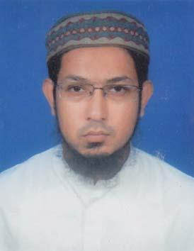 | DR. MAZNUN-US-SADAKIN  F/Name: Sarder Matiur Rahman  M/Name: Late Mannujan  BM & DC Reg. No: 43779  NID: 2694811004735  Cell: 01712558596  Address: UHC, Sadar, Gopalgonj  Blood Group: B+
107 | Voter No  LM-2100106  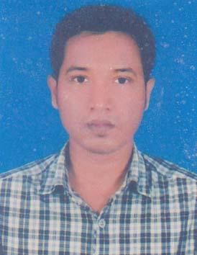 | DR. SHAIKH MOHAMMAD SAJIB  F/Name: Mohammad Abul Kashem Shaikh  M/Name: Kohinoor Begum  BM & DC Reg. No: 65093  NID: 19893513256000036  Cell: 01676641574  Address: Vill: Gosherchar, P.O: Gopalganj, Thana: Gopalganj, Dist- Gopalganj  Blood Group: B+
108 | Voter No  LM-2100107  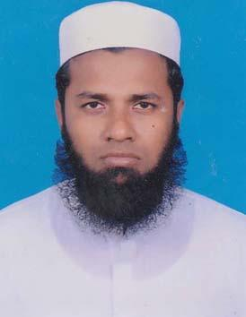 | DR. AKMAN HOSSAIN  F/Name: Forman Molla  M/Name: Laila Begum  BM & DC Reg. No: 54959  NID: 19866125217236678  Cell: 01552336584  Address: Vill: Malibata, Post: Durgapur, P.S: Gopalganj, Dist: Gopalganj  Blood Group: B+
109 | Voter No  LM-2100108  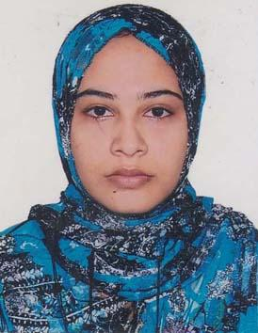 | DR. MAHBUBA ZHUMUR  F/Name: Shafiullah Rahmani  M/Name: Hazera Rahmani  BM & DC Reg. No: 62517  NID: 6125214204220  Cell: 01558307747  Address: Village: Bongram, P.O: Moddho Bongram, P.S+District: Gopalganj  Blood Group: B+
110 | Voter No  LM-2100109  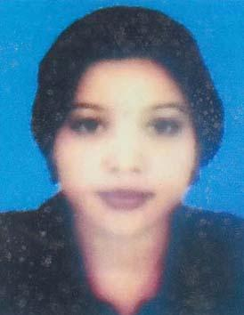 | DR. URMI HUQ  F/Name: Md. Azizul Huq  M/Name: Mrs. Rokeya Huq  BM & DC Reg. No: 54534  NID: 2691649117202  Cell: 01923628912  Address: 133, Chadmari Road, Dist: Gopalgonj  Blood Group: A+
111 | Voter No  LM-2100110  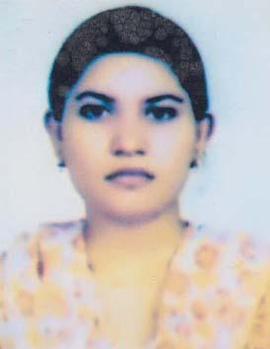 | DR. MOSLEMA HOSSAIN (TANNI)  F/Name: Md. Mosharraf Hossain  M/Name: Jannatul Ferdosh  BM & DC Reg. No: 57983  NID:  Cell: 01788729527  Address: Biswas Vabon, South Alipur, Faridpur  Blood Group: O-
112 | Voter No  LM-2100111  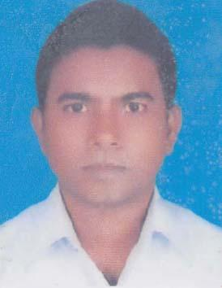 | DR. HITLER BISWAS  F/Name: Hirendra Nath Biswas  M/Name: Sulekha Rani Biswas  BM & DC Reg. No: 55699  NID: 3513260192876  Cell: 01823230704  Address: Sheikh Sayera Khatun Medical College, Gopalganj.  Blood Group: A+
113 | Voter No  LM-2100112  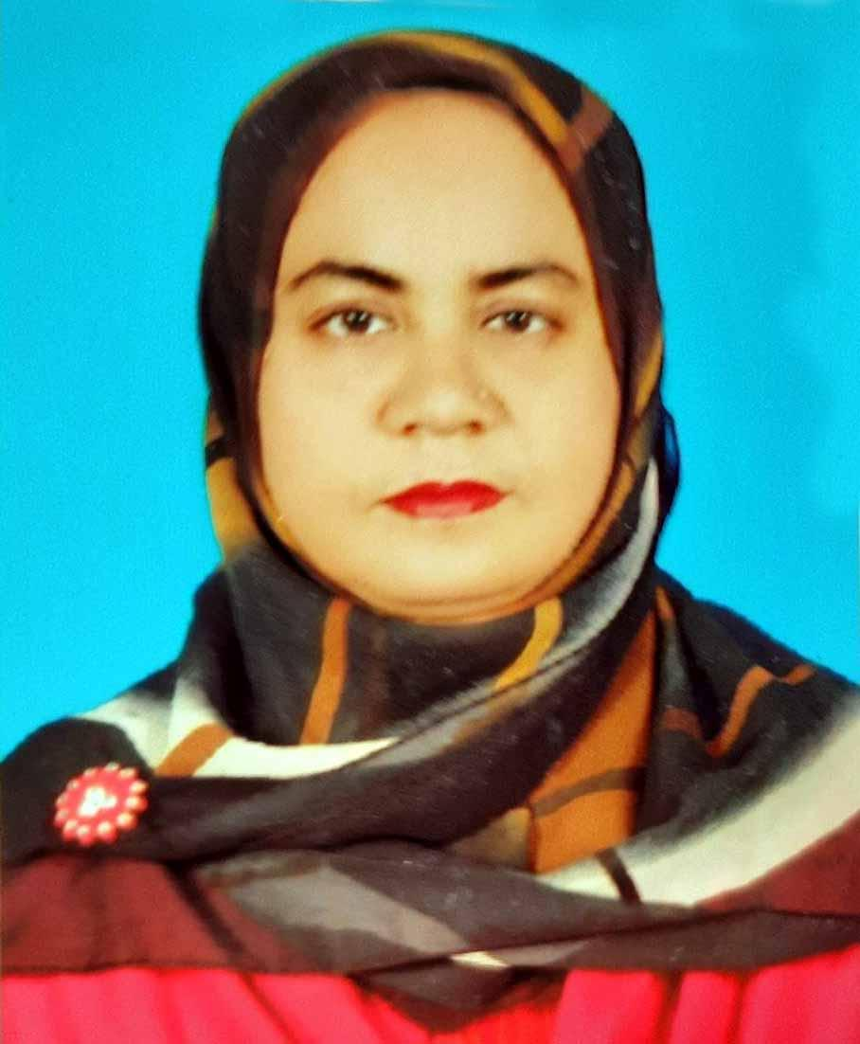 | DR. KAMRUNNAHAR SHEULI  F/Name: Hazi Moinuddin Ahmed  M/Name: Mrs. Saleha Khatoon  BM & DC Reg. No: 26580  NID: 3523209135521  Cell: 01711450752  Address: UHC, Muksudpur, Gopalgonj  Blood Group: B+
114 | Voter No  LM-2100113  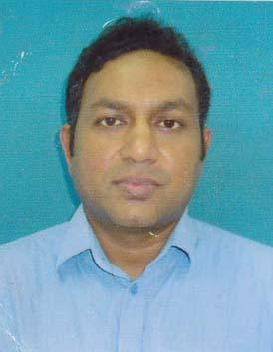 | DR. MANAB RANJAN GHOSH  F/Name: Late Nitya Ranjan Ghosh  M/Name: Saroj Prova Ghosh  BM & DC Reg. No: 59996  NID: 3514327454594  Cell: 01827211335  Address: Vil. Jatgram, Katham Darbas- To, P.O. Jonasur, Kasiani, Gopalgonj  Blood Group: O-
115 | Voter No  LM-2100114  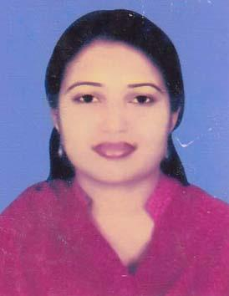 | DR. MOON MOON SAHA  F/Name: Atul Kumar Saha  M/Name: Mira Saha  BM & DC Reg. No: 58314  NID: 19860695112193462  Cell: 01834564510  Address: C/O: Dr. Shuvamay Sarkar, Vill+Post: Singa, Upazill: Kashiani, Dist: Gopalganj  Blood Group: A+
116 | Voter No  LM-2100115  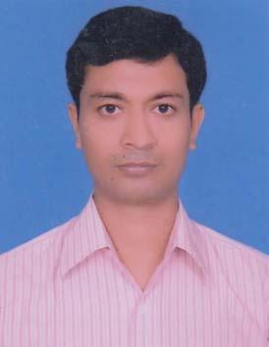 | DR. SHUVAMAY SARKAR  F/Name: Sarajit Kumar Sarkar  M/Name: Niva Rani Datta  BM & DC Reg. No: 49883  NID: 19813523204000001  Cell: 01818364848  Address: C/O: Sarajit Kumar Sarkar, Vill+Post: Singa, Upazilla: Kashiani, Dist: Gopalgonj  Blood Group: A+
117 | Voter No  LM-2100116  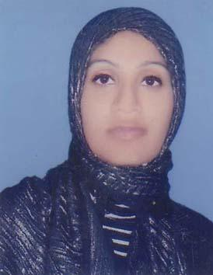 | DR. RABEYA KHATUN  F/Name: Md. Abu Bakar Biswas  M/Name: Mahmuda Begum  BM & DC Reg. No: 59657  NID: 19886125215283714  Cell: 01758542401  Address: Vill-Khagrabaria, P.O- Orakandi, P.S- Kashiani, Dist- Gopalgonj  Blood Group: B+
118 | Voter No  LM-2100117  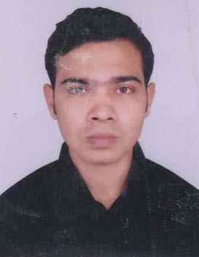 | DR, RAYHAN ISLAM SHOVON  F/Name: Md. Amirul Islam  M/Name: Rehana Akhter  BM & DC Reg. No: 62556  NID:  Cell: 01716415552  Address: Muksudpur, Dist: Gopalganj  Blood Group:
119 | Voter No  LM-2100118  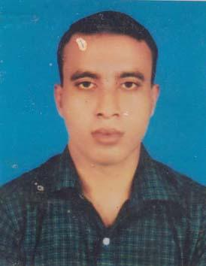 | DR. JAHIDUL ISLAM  F/Name: Md. Siddiqur Rahaman  M/Name: Ashfiara Begum  BM & DC Reg. No: 55664  NID: 3515113528594  Cell: 01911784852  Address: Upazilla Health Complex, Kotalipara, Dist: Gopalgonj  Blood Group: O+
120 | Voter No  LM-2100119 | DR. AHMEDUR RAHMAN SABUJ  F/Name: Md. Atiar Rahman  M/Name: Rekha Begum  BM & DC Reg. No: 59759  NID: 6125217227350  Cell: 01674635580  Address: Doctor\'s Quarter, Upagila Health Complex, Muksudpur, Dist: Gopalganj  Blood Group: B+
121 | Voter No  LM-2100120  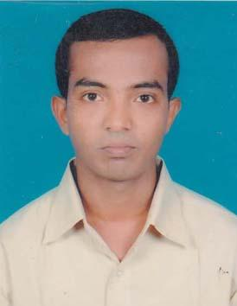 | DR. SAMIR ADHIKARY  F/Name: Bhagyadhar Adhikary  M/Name: Alo Adhikary  BM & DC Reg. No: 62100  NID: 3515147582918  Cell: 01913467523  Address: Vill- Kandi, P.O- Kandi, Upazila- Kotalipara, Dist- Gopalganj  Blood Group: A+
122 | Voter No  LM-2100121 | RATHIN HALDER  F/Name:  M/Name:  BM & DC Reg. No: 57182  NID:  Cell: 01717560091  Address: Kotalipara UHC, Gopalgonj  Blood Group: O+  TRANSFERED to BMA Dhaka City  LM-1405543
123 | Voter No  LM-2100122 | DR. UTTAM ROY  F/Name: Rati Kanta Roy  M/Name: Maya Roy  BM & DC Reg. No: 60622  NID: 0695111184771  Cell: 01917495223  Address: Upozila Health Complex, Kotalipara, Gopalgonj  Blood Group: B+
124 | Voter No  LM-2100123  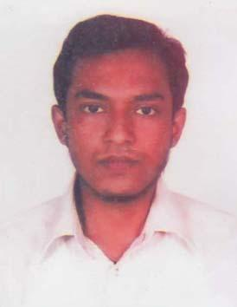 | DR. MD. ABDULLAH SAEED KHAN  F/Name: Md. Shafi Uddin Khan  M/Name: Monowara Begum  BM & DC Reg. No: 54107  NID: 19862691648034072  Cell: 01823210718  Address: Doctor\'s Quarter, Tungipara, Gopalgonj  Blood Group: B+
125 | Voter No  LM-2100124  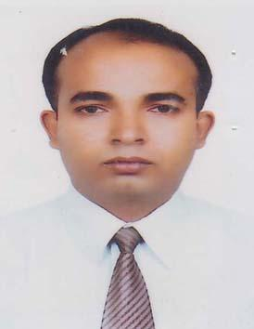 | DR. SABITABRATA BAIN  F/Name: Sachindra Nath Bain  M/Name: Bhabani Bain  BM & DC Reg. No: 45079  NID:  Cell: 01611262728  Address: Sheikh Sayera Khatun Medical College, Gopalgonj  Blood Group: O+
126 | Voter No  LM-2100125  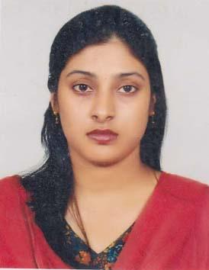 | DR. SHAHANA KHANAM  F/Name: Golam Mostofa Khan  M/Name: Kulsum Begum  BM & DC Reg. No: 54787  NID: 1592824534341  Cell: 01717419749  Address: 158, Shobujbag Road, Chandmari, Gopalganj  Blood Group: B+
127 | Voter No  LM-2100126  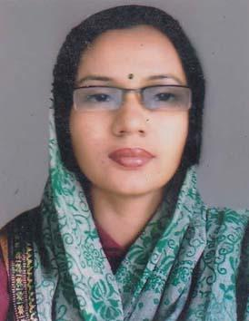 | DR. MAJEDA KHANAM  F/Name: Mokim Boktiar  M/Name: Tahmina Mokim  BM & DC Reg. No: 55630  NID: 19850695112193597  Cell: 01919465564  Address: UHC, Tungiipara, Gopalgonj  Blood Group: AB+
128 | Voter No  LM-2100127  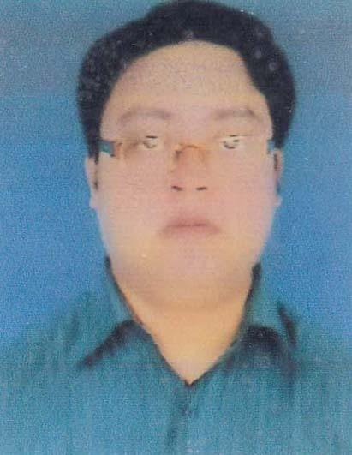 | DR. MOHAMMAD MONJURUL HAQUE  F/Name: Mohammad Fazlul Haque  M/Name: Rowsan Ara  BM & DC Reg. No: 42579  NID: 2650898508916  Cell: 01556398112  Address: Vill, Post & Thana: Tungipara, Dist: Gopalgonj  Blood Group: B+
129 | Voter No  LM-2100128  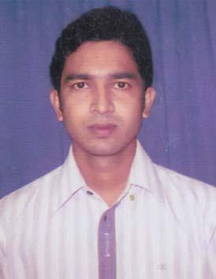 | DR. MD. RAIHANUL ISLAM EMON  F/Name: Md. Mujibur Rahman  M/Name: B.M. Rina Parves  BM & DC Reg. No: 57535  NID: 6125217227039  Cell: 01717094306  Address: Flat# 5, Doctor\'s Quarter, UHC, Kashiani, Gopalgonj  Blood Group: O+
130 | Voter No  LM-2100129  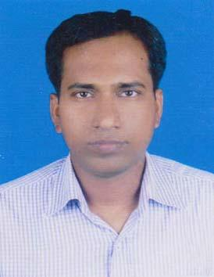 | DR. KAMALESH CHANDRA BASU  F/Name: Keshab Lal Basu  M/Name: Manoda Basu  BM & DC Reg. No: 37817  NID: 3523209135628  Cell: 01712935218  Address: Sadar Hospital- Gopalgonj  Blood Group: B-
131 | Voter No  LM-2100130  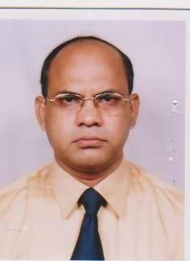 | DR. MD. ABUL KALAM AZAD  F/Name: Late Kawsar Ali Tarafder  M/Name: Mrs. Anwara Begum  BM & DC Reg. No: 20852  NID:  Cell:  Address: Sheikh Fazilatunnesa Muzib Eye Institute & Traning Hospital, Gopalganj  Blood Group: B+
132 | Voter No  LM-2100131  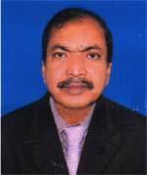 | Dr. Bimal Krishna Bain  F/Name: Basudeb Bain  M/Name: Saraswati Bain  BM & DC Reg. No: 13037  NID: 4795128492048  Cell: 01712651908  Address: 243, Bagchibari Road, Gopalgonj  Blood Group: A+
133 | Voter No  LM-2100132  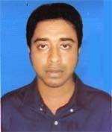 | DR. SHUBHRA DEB HIRA  F/Name: Shankar Kumar Hira  M/Name: Anjali Biswas  BM & DC Reg. No: 71697  NID: 19909196227000188  Cell: 01688035425  Address: House No-169, Janata Road, Gopalgonj  Blood Group: O+
134 | Voter No  LM-2100133  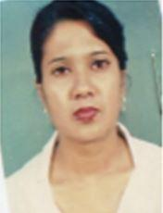 | DR. SHARMISTHA GHOSAL  F/Name: Nirmal Chandra Ghosal  M/Name: Mrs. Mamata Ghosal  BM & DC Reg. No: 31312  NID: 19800111431057331  Cell: 01716868645  Address: Doctor\'s Quarter, 250 Beded General Hospital, Gopalgonj, 2nd floor, 250.  Blood Group: B+
135 | Voter No  LM-2100134  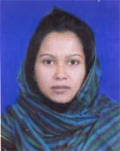 | DR. PAPIA HEVEN  F/Name: S.m. Shahbuddin  M/Name: Tahamina Prova  BM & DC Reg. No: 47559  NID: 4795129505135  Cell: 01677855978  Address: Sheikh Sayera Khatun Medical College Hospital, Gopalgonj  Blood Group: O+
136 | Voter No  LM-2100135  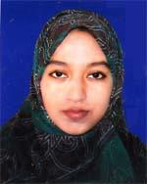 | DR. SK. AFRINA JAHAN  F/Name: Sk. Ashraf Ali  M/Name: Jahanara Khatun  BM & DC Reg. No: 63299  NID: 8198510364380  Cell: 01722191343  Address: Vill: Bandal, P.O- Kotalipara, Dist-Gopalgonj  Blood Group: B+
137 | Voter No  LM-2100136  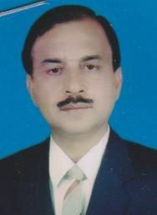 | DR. RABINDRA NATH SARKAR  F/Name: Gopal Chandra Sarker  M/Name:  BM & DC Reg. No:  NID:  Cell:  Address: Gopalgonj Surgical Clinic, 501, Gheypara, Gopalgonj.  Blood Group:
138 | Voter No  LM-2100137  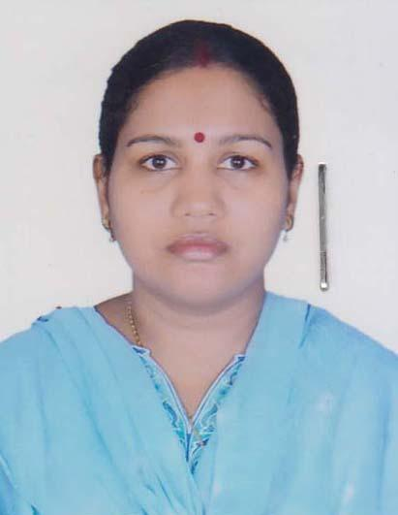 | DR. SANGEETA SARKER  F/Name: Manaranjan Sarker  M/Name: Dipali Sarker  BM & DC Reg. No: 47216  NID: 2617233981082  Cell: 01736804039  Address: Medical Officer\'s Quater 250 Beded Gopalgonj Sadar Hospital, Gopalgonj.  Blood Group: O+
139 | Voter No  LM-2100138  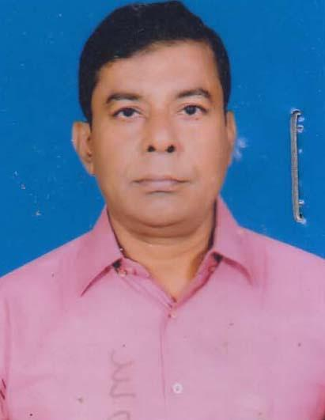 | DR. Q RABIUL ISLAM  F/Name: Late Q. Nasiruddin Ahmed  M/Name: Late Q. Hena  BM & DC Reg. No: 7300  NID: 4124703030983  Cell: 01715855179  Address: Gopalganj Diabetic Center(Samity), Gopalgonj.  Blood Group: B+
140 | Voter No  LM-2100139  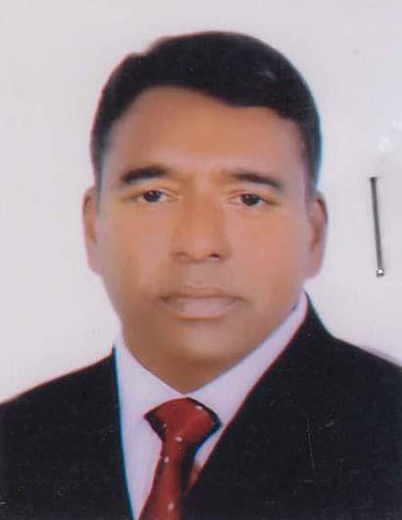 | DR. MD. JAHANGIR HOSSAIN  F/Name: Late Mozaharul Islam  M/Name: Mst. Fatema Khatun  BM & DC Reg. No: 22389  NID: 8826703222965  Cell: 01711875282  Address: Alfadanga Health Complex, Alfadanga, Faridpur.  Blood Group: A+
141 | Voter No  LM-2100140  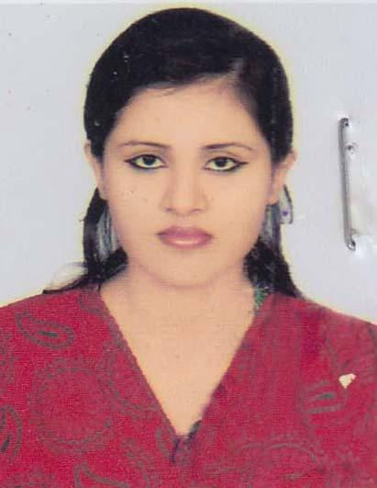 | DR. MUMTAHENA ZAKIR  F/Name: Md. Zakir Hossain  M/Name: Nasima Begum  BM & DC Reg. No: 84520  NID: 4197835657  Cell: 01705201123  Address: Vill: Nilfa, P.O: Nilfa Boyra, P.S: Tungipara, Dist: Gopalgonj.  Blood Group: B+
142 | Voter No  LM-2100141  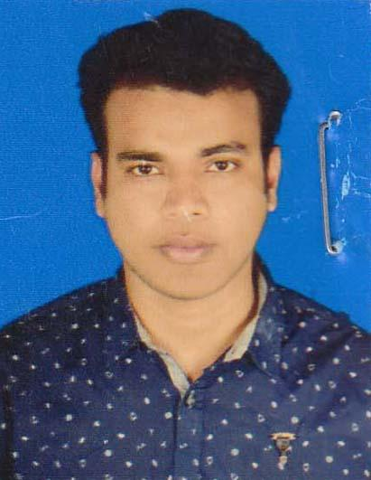 | DR. MOHAMMAD NURUL AFSAR  F/Name: Mohammad Nurul Amin  M/Name: Mohsena Khatoon  BM & DC Reg. No: 84481  NID: 19923012577000276  Cell: 018132955840  Address: Sheikh Sayera Khatun Medical College Hostel- 01, Gopalganj Sadar, Gopalganj.  Blood Group: O+
143 | Voter No  LM-2100142  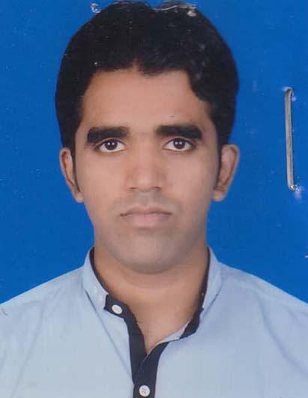 | DR. ROBEL DAS  F/Name: Kajal Das  M/Name: Rina Das  BM & DC Reg. No: 84502  NID: 19923523209000106  Cell: 0181793488  Address: Sheikh Sayera Khatun Medical College Hostel-01, Gopalgonj Sadar, Gopalganj.  Blood Group: B+
144 | Voter No  LM-2100143  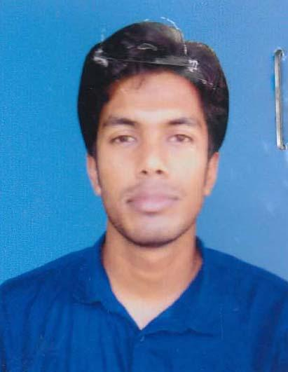 | DR. AL NOMAN  F/Name: Shahab Uddin  M/Name: Asma Yasmin  BM & DC Reg. No: 84498  NID: 19926118840000090  Cell: 01737110879  Address: Sheikh Sayera Khatun Medical College Hostel-01, Gopalgonj Sadar, Gopalgonj.  Blood Group: O+
145 | Voter No  LM-2100144  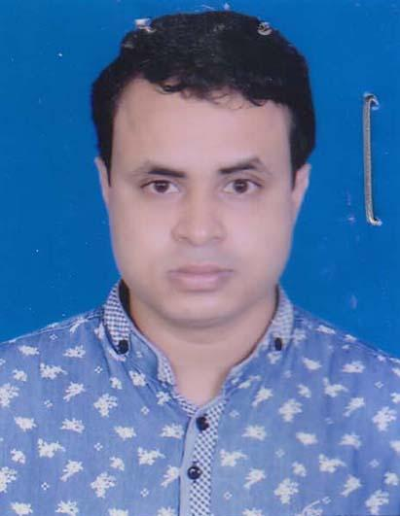 | DR. SHOVAN ACHARJEE  F/Name: Jugal Kishore Acharjee  M/Name: Bandana Acharjee  BM & DC Reg. No: 84503  NID: 1992611866000035  Cell: 01835052990  Address: Sheikh Sayera Khatun Medical College Hostel-01, Gopalgonj Sadar, Gopalgonj.  Blood Group: O+
146 | Voter No  LM-2100145  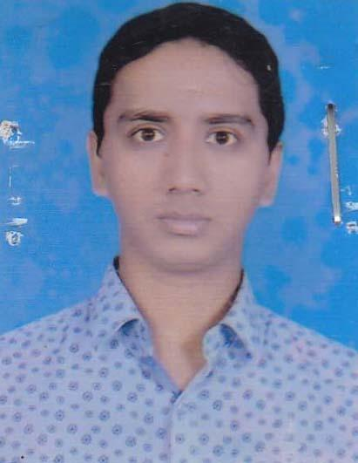 | DR. ANUP KUMAR DAS  F/Name: Sadesh Chandra Das  M/Name: Bulu Rani Das  BM & DC Reg. No: 84480  NID: 19932696805000069  Cell: 01764627345  Address: Sheikh Sayera Khatun Medical College Boy\'s Hostel-01, Gopalganj Sadar, Gopalganj.  Blood Group: A+
147 | Voter No  LM-2100146  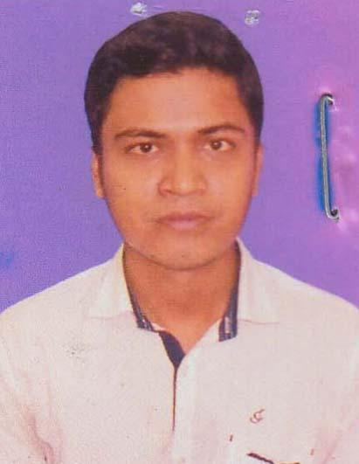 | DR. SUMON BISWAS  F/Name: Suvash Biswas  M/Name: Sushama Biswas  BM & DC Reg. No: 84486  NID: 19943523209000081  Cell: 01755913618  Address: Sheikh Sayera Khatun Medical College Hostel-01, Gopalganj Sadar, Gopalganj.  Blood Group: O+
148 | Voter No  LM-2100147  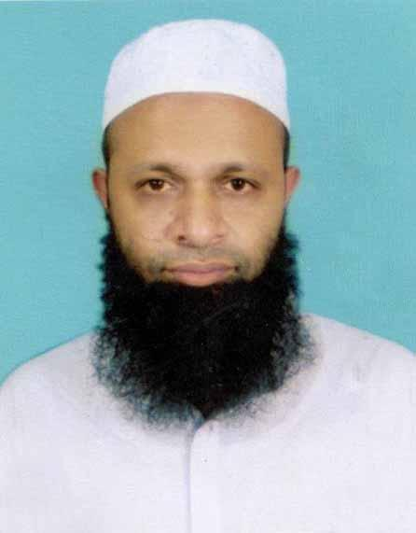 | DR. MD. MAHMUDUR RAHMAN  F/Name: Md. Lutfor Rahman  M/Name: Late Rezia Begum  BM & DC Reg. No: 40454  NID: 19792911885000016  Cell: 01715778765  Address: Asstt Director, Hospital 1, Directorate General Of Health Services, Mohakhali, Dhaka.  Blood Group: B+
149 | Voter No  LM-2100148  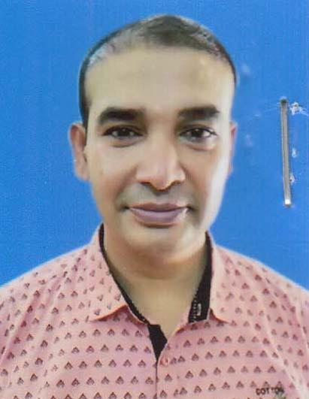 | DR. MOHAMMAD FAZLUL HAQUE  F/Name: Mohammad Abul Kashem  M/Name: Mosammad Kulsum Begum  BM & DC Reg. No: 37409  NID: 2914723356245  Cell: 01716046695  Address: 63/B, Waith Tower, Jhilatuli Faridpur.  Blood Group: B+
150 | Voter No  LM-2100149  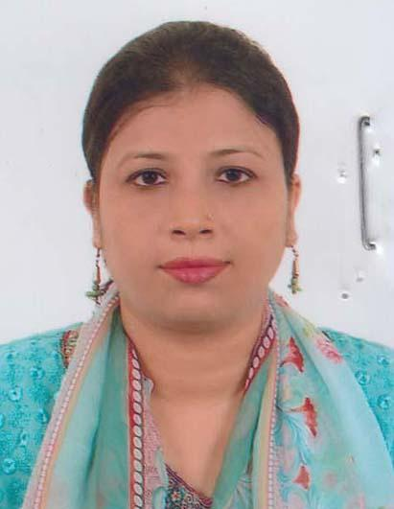 | DR. RUMANA AFROZ  F/Name: Md. Abdur Rouf  M/Name: Momtaz Begum  BM & DC Reg. No: 36178  NID:  Cell: 01824816475  Address: UHC, Muksudpur, Gopalgonj.  Blood Group: B+
151 | Voter No  LM-2100150  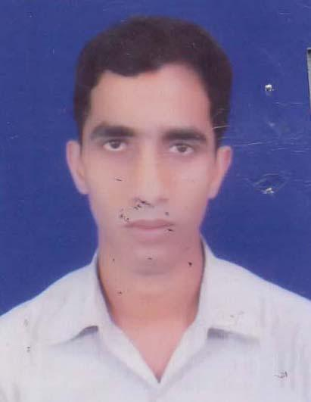 | DR. VISHMADEB MONDOL  F/Name: Haran Chandra Mondol  M/Name: Kalati Rani Mondol  BM & DC Reg. No: 73289  NID: 8207146054  Cell: 01855204855  Address: Doctors Quartar, Upazilla: Health Complex, Muksudpur, Gopalgonj.  Blood Group: B+
152 | Voter No  LM-2100151  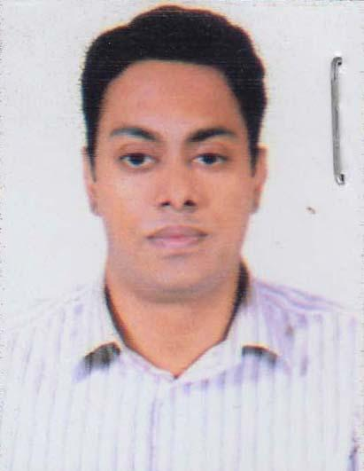 | DR. MOHAMMED EHSANUL HAQUE  F/Name: Md. Imdadul Haque  M/Name: Parvin Haque  BM & DC Reg. No: 75012  NID: 8663030248  Cell: 01674356565  Address: Hospital Quarter, Upazilla Health Complex, Tungipara, Gopalganj.  Blood Group: B+
153 | Voter No  LM-2100152  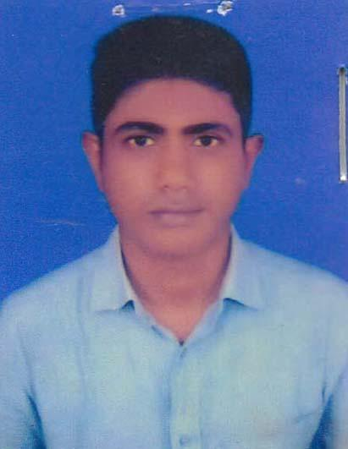 | DR. GOUTAM KUMAR MONDAL  F/Name: Profulla Chandra Mondal  M/Name: Basanti Rani Roy  BM & DC Reg. No: 46421  NID:  Cell: 01819068119  Address: Junior Consultant (Medicine), Tungipara UHC, Gopalganj.  Blood Group: O+
154 | Voter No  LM-2100153  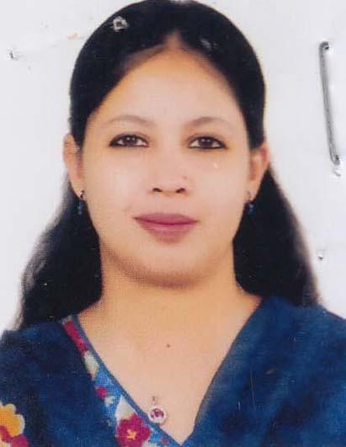 | DR. NAFISA SHAMSUN NAHAR  F/Name: Muhammad Nasir Uddin  M/Name: Khaleda Nurun Nahar  BM & DC Reg. No: 40916  NID:  Cell: 01712088023  Address: Tungipara Upazilla Health Complex Quarter, Gopalgonj.  Blood Group: O+
155 | Voter No  LM-2100154  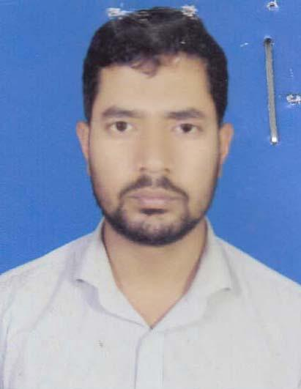 | DR. TALHA AHMED  F/Name: Shafiuddin Ahmed  M/Name: Rahima Khatun  BM & DC Reg. No: 67048  NID: 19883323021499661  Cell: 01913505848  Address: Doctors Dormiforj, Tungipara UHC, Tungipara, Gopalganj.  Blood Group: O+
156 | Voter No  LM-2100155  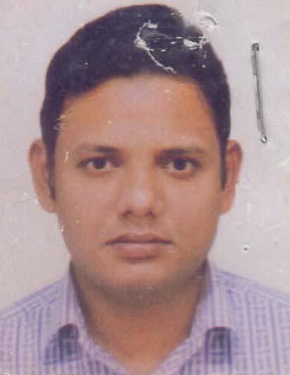 | DR. MOHAMMAD MAHBUBUR RAHMAN  F/Name: Md. Chand Miah Khandakar  M/Name: Masuda Khandaker  BM & DC Reg. No: 66129  NID: 19889196201102272  Cell: 01517044171  Address: Tungipara Upazilla Health Complex Quarter, Tungipara, Gopalganj.  Blood Group: A+
157 | Voter No  LM-2100156  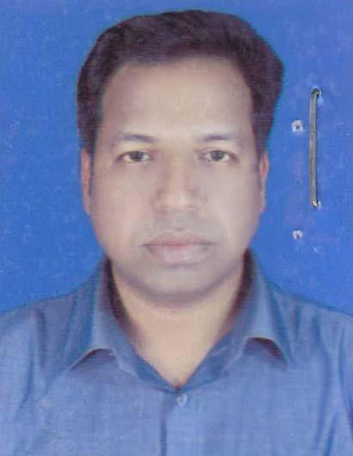 | DR. JAYDEV KUMER SARKER  F/Name: Sachindra Nath Sarker  M/Name: Jayanti Rani Sarker  BM & DC Reg. No: 51023  NID: 8198510366841  Cell: 01710440008  Address: UHC, Tungipara, Gopalgonj.  Blood Group: B+
158 | Voter No  LM-2100157  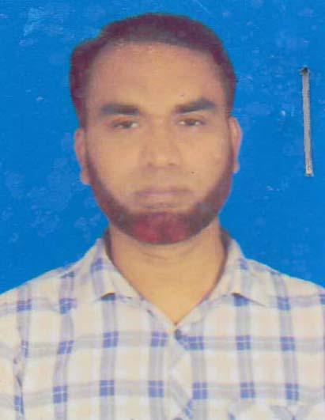 | DR. MD. GOLAM SARWAR  F/Name: Md. Noor Islam Khan  M/Name: Mrs. Halima Begum  BM & DC Reg. No: 44126  NID: 1324502918742  Cell: 01713649111  Address: UHC, Tungipara, Gopalganj.  Blood Group: O+
159 | Voter No  LM-2100158  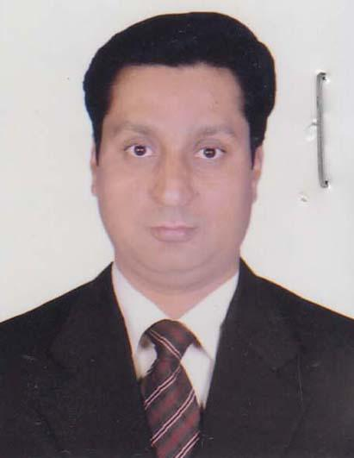 | DR.MAHABUBUR RAHMAN  F/Name: Late Mohammed Mozaher Uddin Bhuiya  M/Name: Shahanara Begum  BM & DC Reg. No: 30593  NID: 35132153407138  Cell: 01711231972  Address: Doctors Quater Sadar Hospital, Gopalganj.  Blood Group: A+
160 | Voter No  LM-2100159  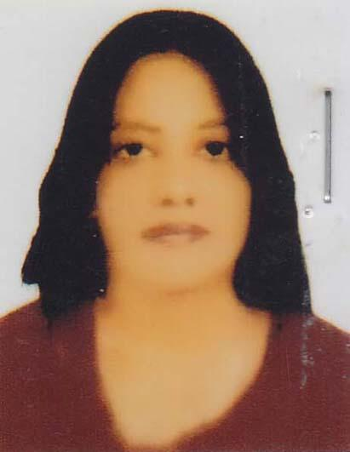 | DR. SHAMIMA ISLAM  F/Name: Md. Sirajul Islam  M/Name: Mrs. Tahmina Islam  BM & DC Reg. No: 49946  NID: 2650898256810  Cell: 01717578147  Address: Doctors Quatar, Sadar Hospital, Gopalganj.  Blood Group: B+
161 | Voter No  LM-2100160  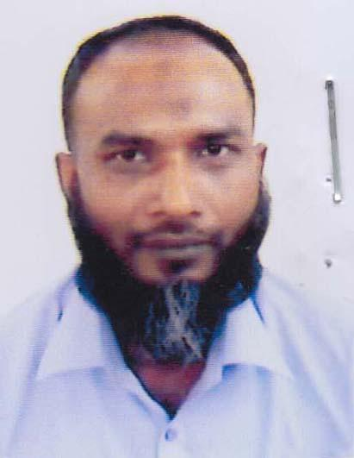 | DR. JINNAT HOSSAIN  F/Name: Md. Akbar Hossain  M/Name: Sanjida Begum Poly  BM & DC Reg. No: 39537  NID: 64129214421  Cell: 01681590527  Address: 205, Asrom Road, Mohammad Para, Gopalganj.  Blood Group: B+
162 | Voter No  LM-2100161  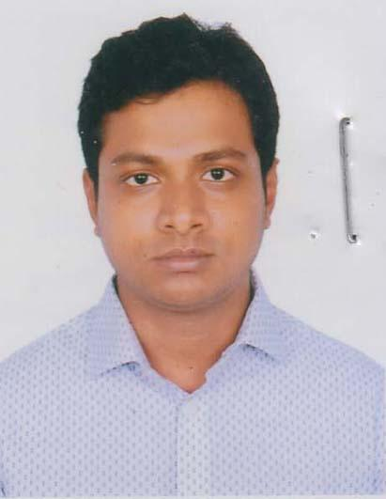 | DR. BUDDHADEV SARKAR  F/Name: Tanmaya Sarkar  M/Name: Bani Biswas  BM & DC Reg. No: 66622  NID: 6879096474  Cell: 01747816429  Address: 168, Janata Road, Gopalgonj.  Blood Group: O+
163 | Voter No  LM-2100162  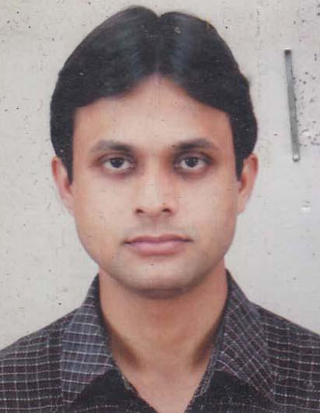 | DR. KOUSHIK SIKDER  F/Name: Niranjan Kumar Sikder  M/Name: Maya Rani Sikder  BM & DC Reg. No: 43016  NID: 1454121274  Cell: 01716848083  Address: UHC, Tungipara, Gopalgonj.  Blood Group: O+
164 | Voter No  LM-2100163  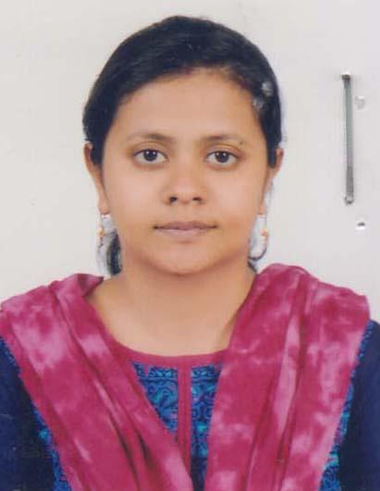 | DR. SHILPI SAMADDER  F/Name: Ram Krishna Samadder  M/Name: Rani Bala Samadder  BM & DC Reg. No: 56990  NID: 2924709173644  Cell: 01717536837  Address: UHC, Tungipara, Gopalgonj.  Blood Group: B+
165 | Voter No  LM-2100164  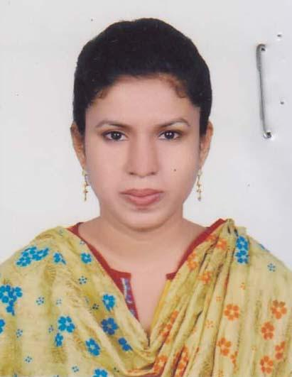 | DR. TAMANNA RAHMAN  F/Name: Md. Fazlur Rahman  M/Name: Zosna Rahman  BM & DC Reg. No: 71536  NID: 19912924707000108  Cell: 01730163337  Address: Doctors Dormitory, Upazilla Health Complex, Tungipara, Gopalganj.  Blood Group: O+
166 | Voter No  LM-2100165  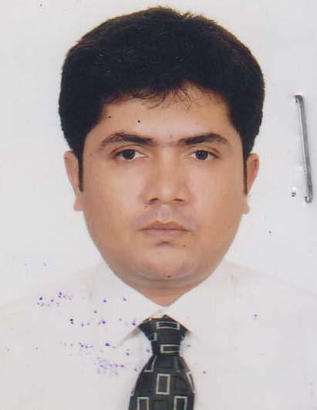 | DR. MANISANKAR BALA  F/Name: Prosanto Bala  M/Name: Pushpa Bala  BM & DC Reg. No: 69760  NID: 5521587773  Cell: 01731987299  Address: Vill: Krishnapur, Post: Boalkali, Thana: Gopalgonj Sadar, Dist: Gopalgonj.  Blood Group: O+
167 | Voter No  LM-2100166  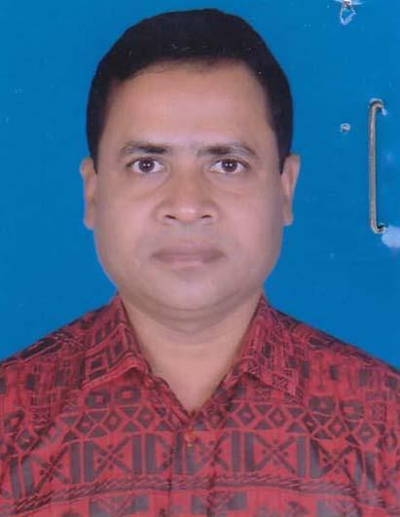 | DR. PARESH CHANDRA HALDER  F/Name: Brojendra Nath Halder  M/Name: Kanok Prova Halder  BM & DC Reg. No: 34913  NID: 2627201650680  Cell: 01712112597  Address: Sheikh Sayera Khatun Medical College, Gopalgonj.  Blood Group: O+
168 | Voter No  LM-2100167  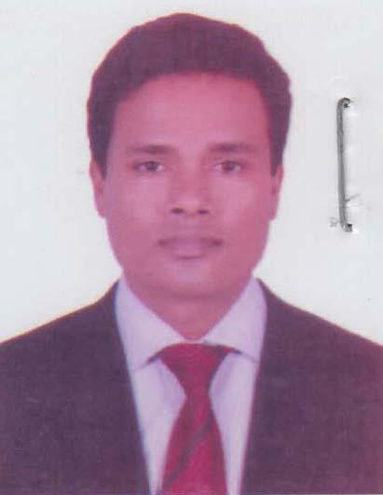 | DR. TAPAN KUMAR MONDAL  F/Name: Gour Dash Mondal  M/Name: Bimala Mondal  BM & DC Reg. No: 37679  NID: 0111431057332  Cell: 01711006273  Address: Doctors Quarter, C-6, Sadar Hospital, Gopalgonj.  Blood Group: B+
169 | Voter No  LM-2100168  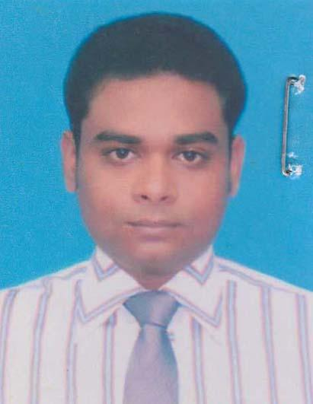 | DR. MD. ASADUZZAMAN HOWLADER  F/Name: Md. Abul Kashem Howlader  M/Name: Momtaz Begum  BM & DC Reg. No: 47146  NID: 2355484367  Cell: 01919335151  Address: Sk. Fazilatunnesa Mujib Eye Hospital, Gopalgonj.  Blood Group: O+
170 | Voter No  LM-2100169  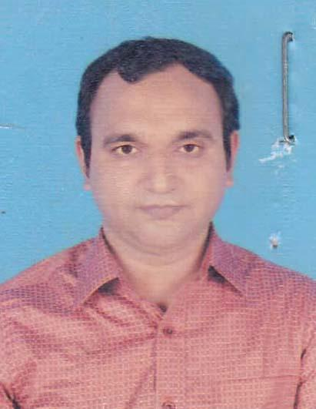 | DR. DIDAR HOSEN  F/Name: Md. Kaum Mia  M/Name: Dinara Begum  BM & DC Reg. No: 70455  NID: 19903515811000104  Cell: 01742040918  Address: Doctor\'s Quarter, UHC, Kashiani, Gopalgonj.  Blood Group: A+
171 | Voter No  LM-2100170  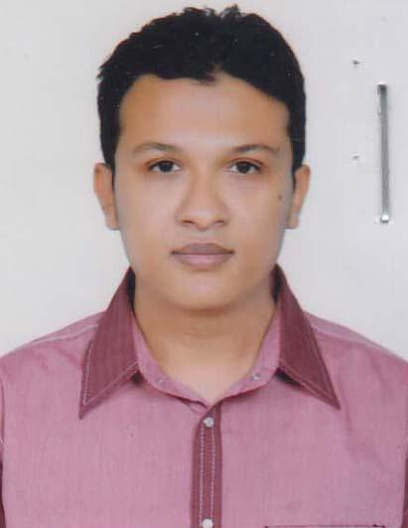 | DR. MOHAMMAD IQBAL KHAN  F/Name: Mohammad Bodiuzzaman Khan  M/Name: Rehana Zaman  BM & DC Reg. No: 54506  NID: 19860695111184768  Cell: 01712950786  Address: Doctor's Quarter, UHC, Kashiani, Gopalgonj.  Blood Group: AB+
172 | Voter No  LM-2100171  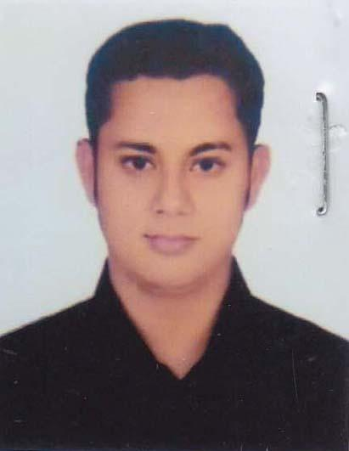 | DR. MD. JUBAER BIN ZAMAN  F/Name: Md. Shohduzzaman  M/Name: Formina Begum  BM & DC Reg. No: 59362  NID: 8199017314602  Cell: 01716772228  Address: Doctor's Quarter, UHC, Kashiani, Gopalgonj.  Blood Group: O+
173 | Voter No  LM-2100172  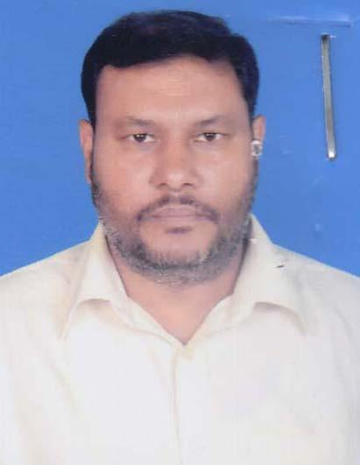 | DR. S.M. ALINOOR ISLAM  F/Name: Sheikh Lutfor Rahman  M/Name: Khayrunnesa Chowdhury  BM & DC Reg. No: 26632  NID: 8221728101  Cell: 01716105178  Address: D-5, Hospital Doctor\'s Quarter, 250 Bedded General Hospital, Gopalganj.  Blood Group: A+
174 | Voter No  LM-2100173  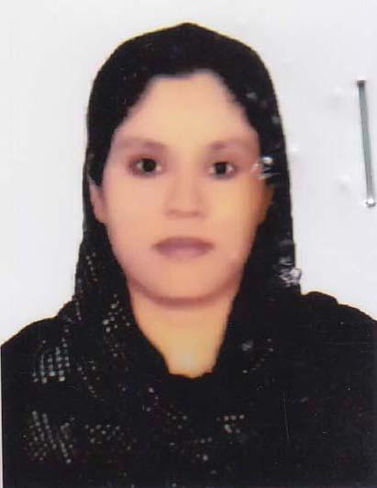 | DR. SUFIA YEASMIN  F/Name: Motaher Matbar  M/Name: Farzana Aktar  BM & DC Reg. No: 48578  NID: 9196211236559  Cell: 01716688180  Address: D-5, Doctor\'s Quartar, 250, Bedded General Hospital, Gopalgonj.  Blood Group: B+
175 | Voter No  LM-2100174  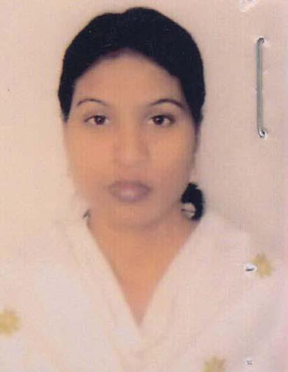 | DR. SUMA RANI PAL  F/Name: Sudev Chandra Pal  M/Name: Sumila Rani Pal  BM & DC Reg. No: 38329  NID: 4820609432281  Cell: 01721817723  Address: Sheikh Sayera Khatun Medical College, Gopalgonj.  Blood Group: A+
176 | Voter No  LM-2100175  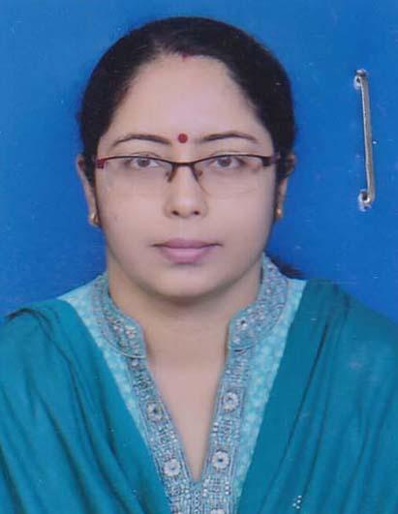 | DR. KANIKA ROY  F/Name: Subir Kumar Roy  M/Name: Maya Roy  BM & DC Reg. No: 32987  NID: 6125205141313  Cell: 01711192719  Address: Sadar Hospital Quarters, Gopalgonj.  Blood Group: O+
177 | Voter No  LM-2100176  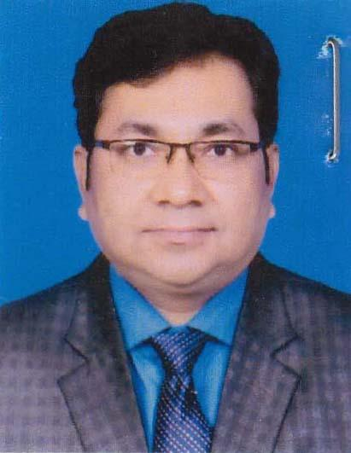 | DR. BIPLAB KUMAR DAS  F/Name: Parimal Kumar Das  M/Name: Anjali Rani Das  BM & DC Reg. No: 28416  NID: 6125205141314  Cell: 01715471171  Address: Sadar Hospital Quarters, GopalGonj.  Blood Group: B+
178 | Voter No  LM-2100177  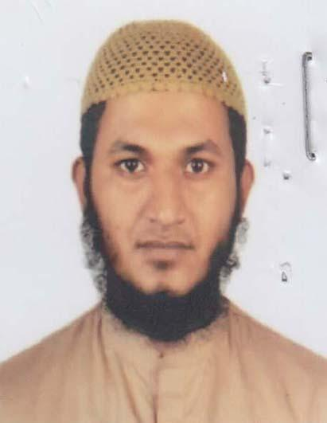 | DR. S.M. SHAMIM HASAN  F/Name: S.M. Idris Ali  M/Name: Rehana Begum  BM & DC Reg. No: 69426  NID: 19904120409000010  Cell: 01729486230  Address: Kashiani Health Complex, Kashiani, Gopalgonj.  Blood Group: O+
179 | Voter No  LM-2100178  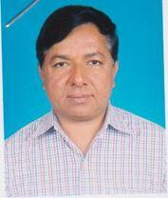 | DR. M.M. MOINUDDIN AHMED  F/Name: Late Munshi Abdul Awal  M/Name:  BM & DC Reg. No: 14021  NID:  Cell:  Address: Dr. Farid Memorial Hospital Prv. Ltd. 90, D.C. Road, Gopalgonj.  Blood Group:
180 | Voter No  LM-2100179  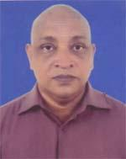 | DR. LIAKAT HOSSAIN  F/Name: Late Md. Manir Hossain  M/Name: Late Saleha Begum  BM & DC Reg. No: 19504  NID: 26199551169588  Cell: 01720130092  Address: Pricipal, Sheikh Sayera Khatun Medical College Gopalgonj.  Blood Group: AB+
181 | Voter No  LM-2100180  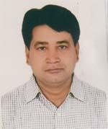 | DR. MD. ZAKIR HOSSAIN  F/Name: Late. Khalilur Rahman  M/Name: Late Nurunnahar Begum  BM & DC Reg. No: 19752  NID: 19656125210175876  Cell: 01711308023  Address: Principal, Sheikh Sayera Khatun Medical College  Blood Group:
182 | Voter No  LM-2100181  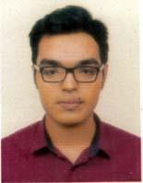 | DR. S M SHAKIBUR RAHMAN  F/Name: Md. Skandar Ali  M/Name: Fazilatun Nassa  BM & DC Reg. No: 84369  NID: 6001578795  Cell: 01710124881  Address: Vill: Kekania, Post: Sultanshahi, Upazila: Gopalganj Sadar, Dist: Gopalganj.  Blood Group: O+
183 | Voter No  LM-2100182  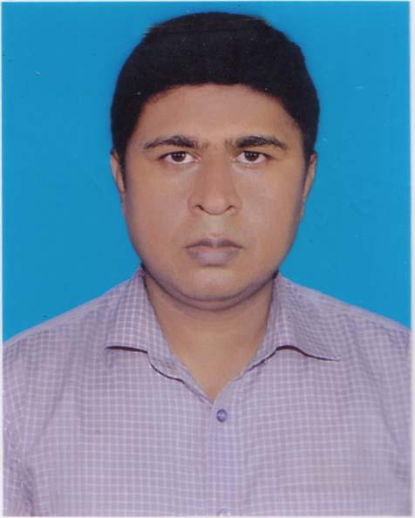 | DR. SHEIK MD JAHANGIR ALAM  F/Name: Sheik Md Jalal Uddin  M/Name: Mrs Khurshida Begum  BM & DC Reg. No: 37775  NID: 4150053041  Cell: 01673458027  Address: Anaesthetist, 250 Bedded General Hospital Gopalgonj.  Blood Group: B+
184 | Voter No  LM-2100183 | DR. BICHITRA KUMAR BISWAS  F/Name: Nepal Chandra Biswas  M/Name: Bina Rani Biswas  BM & DC Reg. No: 77147  NID: 5084460343  Cell: 01915618668  Address: Vill: Bhairobnagor, P.O- Dumuria Upzila: Tungipara, Dis- Gopalganj.  Blood Group: A+
185 | Voter No  LM-2100184 | DR. AMIT SARKAR  F/Name: Dilip Sarkar  M/Name: Anita Sarkar  BM & DC Reg. No: 82698  NID: 3259514135  Cell: 01710692504  Address: 390, Bankpara Gopalganj.  Blood Group: B+
186 | Voter No  LM-2100185 | DR. SANJOY BISWAS  F/Name: Satyangshu Kumar Biswas  M/Name: Dipali Rani Biswas  BM & DC Reg. No: 78415  NID: 8686809875  Cell: 01711069655  Address: 149/2 Bangabandhu Road, Pachuria, Gopalganj Sadar.  Blood Group: B+
187 | Voter No  LM-2100186  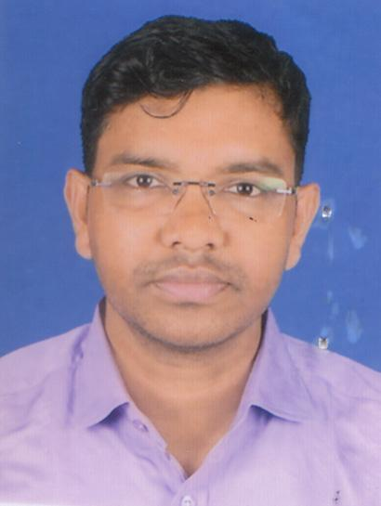 | DR. SOHAG HOWLADER  F/Name: Mujibur Rahman  M/Name: Momtaz Begum  BM & DC Reg. No: 95198  NID: 19942694807000293  Cell: 01515268293  Address: Vill & Post: Sitaikunda, Upazila: Kotalipara, Dist: Gopalganj.  Blood Group:
188 | Voter No  LM-2100187  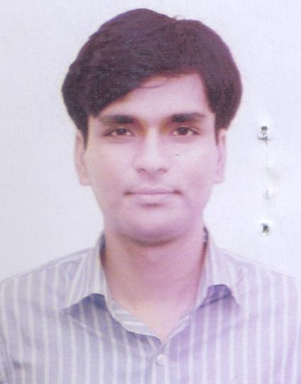 | DR. ANUPAN BARAI LITU  F/Name: Manoranjan Barai  M/Name: Anjali Barai  BM & DC Reg. No: 76841  NID: 3250901760  Cell: 01938071646  Address: 1st floor, Hospital Quarter, Upazila Health Complex, Kotalipara, Gopalganj.  Blood Group: O+
189 | Voter No  LM-2100188  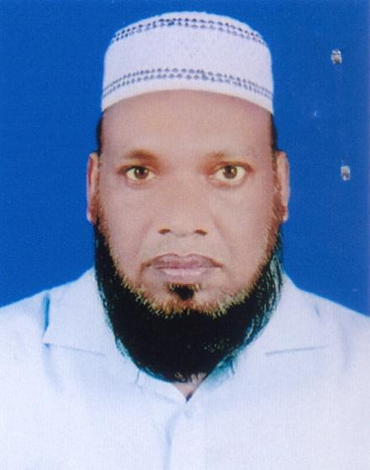 | DR. SK. MD. SHAFIQUL ISLAM  F/Name: Sk. Md. Monowar Hossain  M/Name: Khodeza Begume  BM & DC Reg. No: 24602  NID: 9119400555  Cell: 01715222459  Address: SSKMC, Gopalganj.  Blood Group: AB+
190 | Voter No  LM-2100189  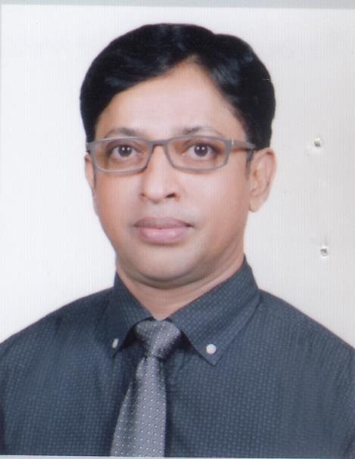 | DR. GOLAM MORSHED MOLLA  F/Name: Abdul Hamid Molla  M/Name: Begum Lutfunnessa  BM & DC Reg. No: 30586  NID: 1938881107  Cell: 01817574626  Address: Professor Biochemistry Dept. Sheikh Sayera Khatun Medical College, Gopalganj  Blood Group: AB+
191 | Voter No  LM-2100190  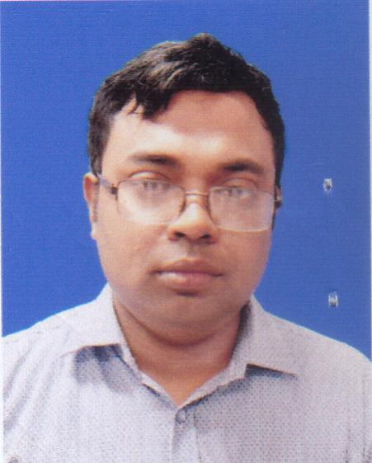 | MD. SAZZAD HOSSAIN  F/Name: Late. Md. Mosharraf Hossain  M/Name: Begum Arefa Hassana  BM & DC Reg. No: 60757  NID: 644973112  Cell: 01705513802  Address: 82 (GHA), Road No: 7, Nirala Residential Area, Khulna, SSKMC, Gopalganj.  Blood Group: A+
192 | Voter No  LM-2100191  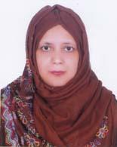 | DR. SALMA AKHTER  F/Name: Abdul Momen Chowdhury  M/Name: Shahida Akhter  BM & DC Reg. No: 30314  NID: 2369402348  Cell: 01712014678  Address: SSKMC, Gopalganj  Blood Group: B+
193 | Voter No  LM-2100192  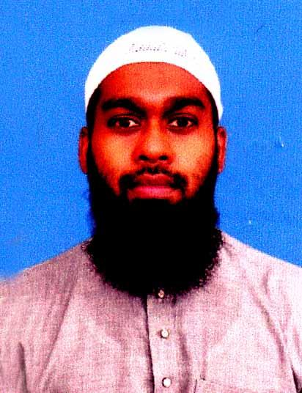 | DR. MD. NAZMUL ISLAM NISSAN  F/Name: Md. Nurul Islam  M/Name: Dewan Nurjahan  BM & DC Reg. No: 59348  NID: 2694811023275  Cell: 01715028138  Address: S.S.K.M.C. Dormatory  Blood Group: O+
194 | Voter No  LM-2100193  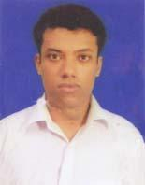 | DR. A.S.M. NURUS SHAFI  F/Name: Md. Abdur Rashid  M/Name: Zannnatun Nesa  BM & DC Reg. No: 90659  NID: 19933523209000078  Cell: 01722964574  Address: Sheikh Sayera Khatun Medical College Gopalganj  Blood Group: B+
195 | Voter No  LM-2100194 | DR. MAFRUHA TAZKIN MILKY  F/Name: Md. Khurshid Alam  M/Name: Mrs. Gowhor Pervin  BM & DC Reg. No: 36901  NID: 2627205550768  Cell: 01819439789  Address: dormetory Bhaban, Sheikh Sayera Khatun Medical College, Gopalganj  Blood Group: B+
196 | Voter No  LM-2100195  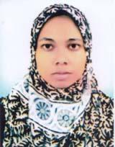 | DR. MANIA PARVIN  F/Name: Md. Abdul Jalil  M/Name: Arju Ara Begum  BM & DC Reg. No: 61906  NID: 19894792104045356  Cell: 01799599077  Address: Muksudpur Upazila Health Complex Muksudpur, Gopalganj.  Blood Group: B+
197 | Voter No  LM-2100196  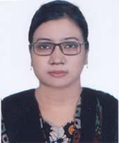 | DR. FLORIDA YALI NIPU  F/Name: Chaitanya Kumar Biswas  M/Name: Deb Rani Biswas  BM & DC Reg. No: 95966  NID: 19943515850000145  Cell: 01766858937  Address: Muksudpur, Upazila Health Complex Gopalganj.  Blood Group: B+
198 | Voter No  LM-2100197 | DR. YASIR ARAFAT NISSAN  F/Name: A.k.m. Giash Uddin  M/Name: Shahina Begum  BM & DC Reg. No: 110573  NID: 1026171353  Cell: 01675737959  Address: Upazilla Health Complex, Muksudpur, Gopalganj.  Blood Group: O+
199 | Voter No  LM-2100198 | DR. JIHAD HOSSEN  F/Name: Kalum Mia  M/Name: Denara Begum  BM & DC Reg. No: 108729  NID: 3752330641  Cell: 01765666557  Address: Vill: Kaunia Post: Bejra-Vatra Thana: Muksudpur Dist: Gopalganj.  Blood Group: A+
200 | Voter No  LM-2100199 | DR. MD. JAHIDUL ISLAM  F/Name: Md. Jahangir Alom  M/Name: Khadiza Begum  BM & DC Reg. No: 90029  NID: 3302340447  Cell: 01316427910  Address: Upazila Health Complex, Muksukpur, Gopalganj.  Blood Group: O+
201 | Voter No  LM-2100200 | DR. ARINDAM BHAKTA  F/Name: Ram Krishna Bhakta  M/Name: Mukti Bhakta  BM & DC Reg. No: 105310  NID: 19943515811000216  Cell: 0184312557  Address: Upazila Health Complex, Muksukpur, Gopalganj.  Blood Group: B+
202 | Voter No  LM-2100201 | DR. TAPAN BHAKTA  F/Name: Noren Bhakta  M/Name: Parul Bhakta  BM & DC Reg. No: 89473  NID: 1918877158  Cell: 01780787713  Address: Muksedpur, Upazila Health Complex, Muksedpur, Gopalganj.  Blood Group: B+
203 | Voter No  LM-2100202  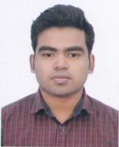 | DR. DIP SAHA  F/Name: Narattam Saha  M/Name: Namita Saha  BM & DC Reg. No: 94959  NID: 3301567644  Cell: 01770335025  Address: Dector's Quarter, Upazilla Health Complex, Muksudpur, Gopalganj.  Blood Group: O+
204 | Voter No  LM-2100203  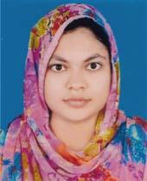 | DR. NAZIAT ALAM JUTHY  F/Name: Mir Mahbub Alam  M/Name: Jesmin Begum  BM & DC Reg. No: 98572  NID: 2853015747  Cell: 01727603089  Address: Muksudpur, Upazila Health Complex, Muksudpur, Gopalganj.  Blood Group: A+
205 | Voter No  LM-2100204 | DR. MOHAMMAD SYEDUZZAMAN JEWEL  F/Name: Sheikh Golam Hasib  M/Name: Momtaz Begum  BM & DC Reg. No: 79692  NID: 6005645418  Cell: 01914898117  Address: Gopalganj Sadar Upazila Health Office.  Blood Group: O+
206 | Voter No  LM-2100205  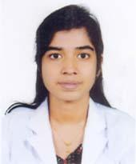 | DR. SUTAPA BISWAS  F/Name: Shyamal Biswas  M/Name: Niyati Biswas  BM & DC Reg. No: 110348  NID: 3705801755  Cell: 01620116708  Address: 61/1, Sahapara, Gopalganj Sadar, Gopalganj.  Blood Group: B+
207 | Voter No  LM-2100206  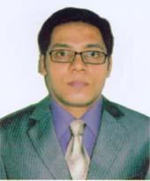 | DR. SHORIF UZ ZAMAN  F/Name: Layek Uz Zaman  M/Name: Payara Zaman  BM & DC Reg. No: 41316  NID: 2695042759289  Cell: 01712153478  Address: Orthopaedic Department, Gopalganj, 250 Bed General Hospital, Gopalganj.  Blood Group: B+
208 | Voter No  LM-2100207  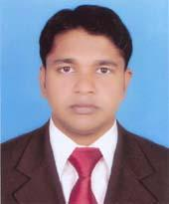 | DR. SUMON ROY  F/Name: Subhash Chandra Roy  M/Name: Annada Rani Biswas  BM & DC Reg. No: 55486  NID: 4798516214746  Cell: 01717322300  Address: Assistant Prof. Department Of Biochemutry Sheikh Sayera Khatun Medical College, Gopalganj.  Blood Group: A+
209 | Voter No  LM-2100208  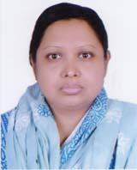 | DR. MITA RAHMAN  F/Name: Habibur Rahman  M/Name: Nilufa Begum  BM & DC Reg. No: 51522  NID: 6125215214553  Cell: 01816495281  Address: H-27, Model School Road, Gopalganj.  Blood Group: A+
210 | Voter No  LM-2100209  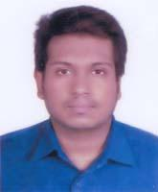 | DR. RAFIZ ABYAZ  F/Name: Md. Ebadullah  M/Name: Afroza Abayed  BM & DC Reg. No: 97353  NID: 1460768565  Cell: 01754063219  Address: Markaz Moholla, Gopalganj.  Blood Group: B+
211 | Voter No  LM-2100210  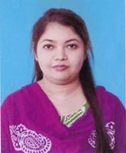 | DR. LABONNO YEASMINE  F/Name: Kazi Anwar Hossain  M/Name: Halima Begum  BM & DC Reg. No: 99275  NID: 2851542544  Cell: 01744397282  Address: 472/1, Markaz Moholla, Gopalganj.  Blood Group: A+
212 | Voter No  LM-2100211  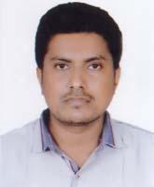 | DR. HILLOL BISWAS  F/Name: Sushil Biswas  M/Name: Usha Biswas  BM & DC Reg. No: 81317  NID: 19922698846000189  Cell: 01842805778  Address: Upazila Health Complex, Kotalipara Gopalganj.  Blood Group: O+
213 | Voter No  LM-2100212  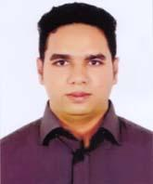 | DR. MD. IBRAHIM MOLLA  F/Name: Md. Mosaraf Molla  M/Name: Monoyara Hossain  BM & DC Reg. No: 74680  NID: 7337361567  Cell: 01791667766  Address: 100 Beded Upazila Health Complex, Kotalipara, Gopalganj.  Blood Group: O-
214 | Voter No  LM-2100213 | DR. MD. RAFIQUZZAMAN  F/Name: Md. Abdul Malek  M/Name: Mrs. Saleha Begum  BM & DC Reg. No: 51391  NID: 7770355811  Cell: 01717378060  Address: 163, Sabujbag, Chandmari Road, Gopalganj Sadar, Gopalganj.  Blood Group: A+
215 | Voter No  LM-2100214  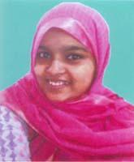 | DR. REHANA SULTANA KANA  F/Name: Md. Abdul Wadud Miah  M/Name: Mrs. Manjuara Wadud  BM & DC Reg. No: 71359  NID: 7300510364  Cell: 01758693656  Address: 163, Sabujbag, Chandmari Road Gopalganj Sadar, Gopalganj.  Blood Group: O+
216 | Voter No  LM-2100215 | DR. NIPA BEPARI  F/Name: Nirmalendu Bepari  M/Name: Promila Bepari  BM & DC Reg. No: 56292  NID: 19840695112194056  Cell: 01672499565  Address: Shaikh Sayera Khatun Medical College Hospital Quarter, Gopalganj.  Blood Group: A+
217 | Voter No  LM-2100216  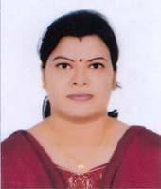 | DR. NANDA SEN GUPTA  F/Name: Mr. Bejoy Sen Gupta  M/Name: Mrs. Shibani Sen Gupta  BM & DC Reg. No: 45648  NID: 1594121841451  Cell: 01819133472  Address: UHC, Kotalipara, Gopalgonj.  Blood Group: B+
218 | Voter No  LM-2100217  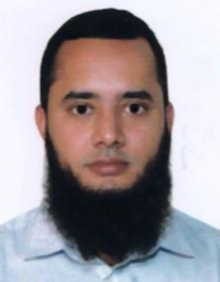 | DR. NAHID HASAN  F/Name: Md. Erad Ali Munshi  M/Name: Rehana Begum  BM & DC Reg. No: 111240  NID: 3309274862  Cell: 01521461926  Address: Noor tower, 4th Floor, Holding 6/3, Janata Road, Bottola, Gopalganj.  Blood Group: O+
219 | Voter No  LM-2100218  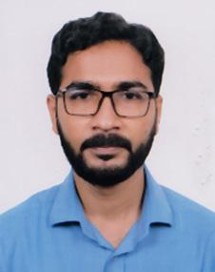 | DR. SHEIKH SAZZAD HOSSAIN  F/Name: Sheikh Torab Ali  M/Name: Safia Begum  BM & DC Reg. No: 82709  NID: 19933514354000077  Cell: 01936689229  Address: Doctors quarter, 100 bedded UHC, Kashiani Gopalganj.  Blood Group: B+
220 | Voter No  LM-2100219  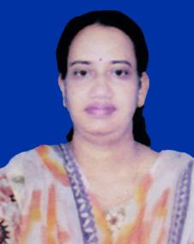 | DR. SMRITI TIKADER  F/Name: Profulla Kumar Tikader  M/Name: Aloka Tikader  BM & DC Reg. No: 42124  NID: 8669418504  Cell: 01715622818  Address: 19/2 Teghoria School Road, Gopalganj Pouroshava, Gopalganj.  Blood Group: B+
221 | Voter No  LM-2100220  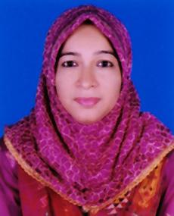 | DR. NAZMUN SEHAR  F/Name: Late. Md. Nizamul Haque Siddiqui  M/Name: Mst. Zinnatun Nessa  BM & DC Reg. No: 42354  NID: 2691649420364  Cell: 01712072849  Address: 250/1, Nobin Bag Gopalganj, Sadar Gopalganj.  Blood Group: O+
222 | Voter No  LM-2100221 | DR. MD. ABDULLAHEL AZAM  F/Name: Proff. Dr. Md. Amanullah  M/Name: Saleha Parvin  BM & DC Reg. No: 42356  NID: 2691649420365  Cell: 01712787138  Address: 250/1, Nobin Bag Gopalganj Sadar Gopalganj.  Blood Group: A+
223 | Voter No  LM-2100222  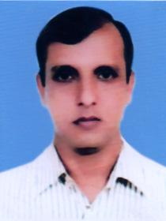 | DR. TAPAS KANTI PODDER  F/Name: Birendra Nath Podder  M/Name: Santi Lata Podder  BM & DC Reg. No: 36660  NID: 5096512248  Cell: 01728892061  Address: Holding No. 00S6-02, Teghoria School Road Teghoria, Gopalganj Sadar, Gopalganj.  Blood Group: B+
224 | Voter No  LM-2100223 | DR. PALASH CHANDRA SARKAR  F/Name: Ranjit Kumar Sarkar  M/Name: Jyotsna Rani Sarker  BM & DC Reg. No: 51306  NID: 8701422407  Cell: 01717605812  Address: Doctor's Quarter, SSKMCH, Gopalganj.  Blood Group: O+
225 | Voter No  LM-2100224 | DR. KAZI MOSHIUL ALAM  F/Name: Kazi Abul Kalam Azad  M/Name: Mrs. Anowara Begum  BM & DC Reg. No: 44025  NID: 2696406684495  Cell: 01736478912  Address: Anesthesia Department, 250 Bedded General Hospital, Gopalganj.  Blood Group: B+
226 | Voter No  LM-2100225  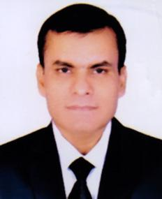 | DR. SUVASH CHANDRA VADURY  F/Name: Subodh Chandra Vadury  M/Name: Mohamaya Vadury  BM & DC Reg. No: 29056  NID: 6921507238590  Cell: 01786860306  Address: Flat: B-7, Junior Consultants' Quarter, 250 Bedded General Hospital, Gopalganj.  Blood Group: A+
227 | Voter No  LM-2100226  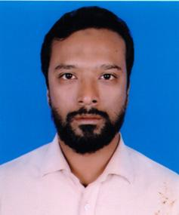 | DR. MD. SAIFUL ISLAM  F/Name: A. Gaffar Talukder  M/Name: Rokeya Begum  BM & DC Reg. No: 53262  NID: 4643783790  Cell: 01757292752  Address: Mahammad para, Gopalganj.  Blood Group: B+
228 | Voter No  LM-2100227  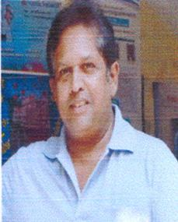 | DR. SHAMS-E-TABRIZ  F/Name: Late. Matiur Rahman  M/Name: Fatema Begum  BM & DC Reg. No: 16166  NID: 2693622445015  Cell: 01711322777  Address: Sheikh Sayera Khatun Medical College Gopalganj.  Blood Group: n_a
229 | Voter No  LM-2100228  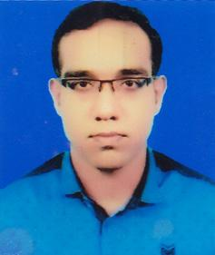 | DR. DIBAKAR BISWAS  F/Name: Dulal Chandra Biswas  M/Name: Bulu Biswas  BM & DC Reg. No: 83063  NID: 7752075247  Cell: 01796428638  Address: Civil Sergeon Office, Gopalganj.  Blood Group: O+
230 | Voter No  LM-2100229 | DR. ABDUL ALIM JEWEL  F/Name: Mohammad Abdul Wahab Molla  M/Name: Late. Jahanara Begum  BM & DC Reg. No: 45699  NID: 5070718274  Cell: 01745813938  Address: 91/2, Abul Basar Road, Khatora, Post- Gopalganj Sadar-8100, Gopalganj.  Blood Group: B+
231 | Voter No  LM-2100230  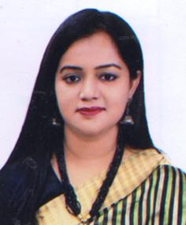 | DR. SANJIDA FARDOUS  F/Name: Dewan Md. Intajul Islam  M/Name: Mrs. Nurun Nahar  BM & DC Reg. No: 45624  NID: 4170728663  Cell: 01745813938  Address: 91/2, Abul Basar Road, Khatora, Gopalganj Sadar-8100, Gopalganj.  Blood Group: O+
232 | Voter No  LM-2100231  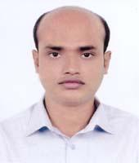 | DR. KAMALESH BAGCHI  F/Name: Kumud Ranjan Bagchi  M/Name: Sushama Bagchi  BM & DC Reg. No: 81330  NID: 8215475487  Cell: 01741312128  Address: Upazilla Health Complex, Tungipara, Gopalganj.  Blood Group: n_a
233 | Voter No  LM-2100232 | DR. SUBRATA KUMAR SAHA  F/Name: Suvash Chandra Saha  M/Name: Anjona Rani Saha  BM & DC Reg. No: 69740  NID: 4619262282  Cell: 01721990399  Address: Sahapara Road, Gopalganj.  Blood Group: AB+
234 | Voter No  LM-2100233 | DR. SHEIKH ZAHIDUL ISLAM  F/Name: Sheikh Harun-or-rashid  M/Name: Nazma Begum  BM & DC Reg. No: 83608  NID: 2359812894  Cell: 01685200112  Address: Upazila Health Complex, Muksudpur, Gopalganj.  Blood Group: A+
235 | Voter No  LM-2100234 | ANU AREFEEN MRIDHA  F/Name: M. Nasimul Islam Mridha  M/Name: Anju Ara Khatun  BM & DC Reg. No: 82690  NID: 19922696415000106  Cell: 01796356696  Address: Muksudpur Upazilla Health Complex.  Blood Group: O+
236 | Voter No  LM-2100235  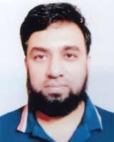 | DR. MUHAMMAD MANIRUZZAMAN  F/Name: Muhammad Rokibul Islam  M/Name: Jaheda Khatun  BM & DC Reg. No: 45309  NID: 2694266786333  Cell: 01937517688  Address: Muksudpur, Gopalganj  Blood Group: B+
237 | Voter No  LM-2100236  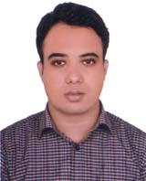 | DR. MD. SALAUDDIN SUZON  F/Name: Md. Amir Hossain  M/Name: Afroza Begum  BM & DC Reg. No: 102139  NID: 9579223737  Cell: 01782044186  Address: Vill: Komlapur. Muksudpur, Gopalganj.  Blood Group: A+
238 | Voter No  LM-2100237 | DR. JEWEL SARKAR  F/Name: Anadi Ranjan Sarkar  M/Name: Souravi Sarkar  BM & DC Reg. No: 92525  NID: 5517263173  Cell: 01737408308  Address: Gopalganj. Sadar Gopalganj.  Blood Group: B+
239 | Voter No  LM-2100238  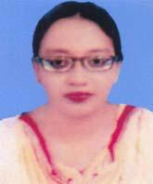 | DR. KHALEDA PANNI  F/Name: Md. Abdul Khaleque  M/Name: Mrs. Sultana Khaleque  BM & DC Reg. No: 42317  NID: 8250056424  Cell: 01791604755  Address: 334, Lichu Bagan Bankpara, Gopalganj.  Blood Group: O-
240 | Voter No  LM-2100239 | NAHID FERDAUSI  F/Name: Abul Kasem Ferdausi  M/Name: Begum Umme Amera  BM & DC Reg. No: 20977  NID: 3736674494  Cell: 01718689771  Address: Director`s Residence, Sheikh Fazilatunnesa Mujib Eye Hospital & Training Institute, Gopalganj.  Blood Group: B+
241 | Voter No  LM-2100240  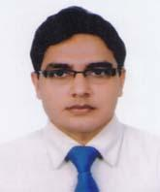 | DR. SAIFUL ISLAM  F/Name: Late. Nurul Islam  M/Name: Kohinur Begum  BM & DC Reg. No: 66866  NID: 8669929070  Cell: 01723955293  Address: Vill: Kekania, Post: Sultanshahi P.S: Gopalganj, Dist: Gopalganj.  Blood Group: B+

